Steps on Azure Cloud –

1. Create a “Resource Group” – (Note – It will be used to create other resources in it)

Specify the parameters like Subscription, Resource Group (Name of Resource Group) & Region (Region for the resource group) then click on Review + Create which will validate the details.

Post validations click on create to complete the resource group creation.

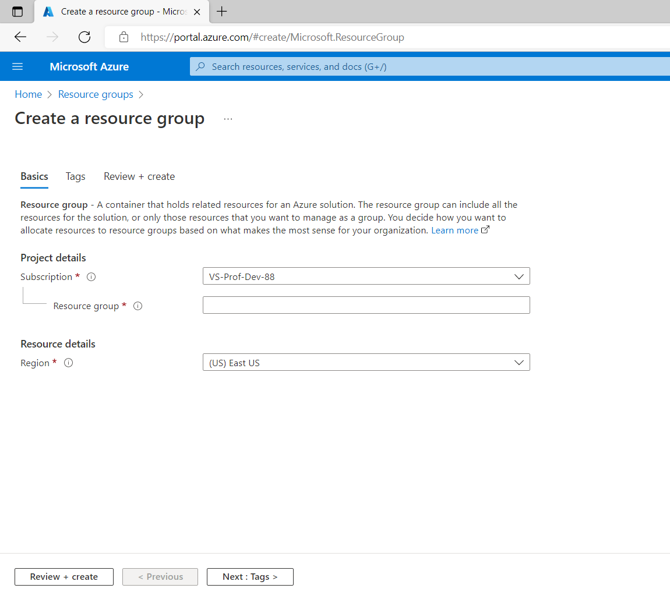

1. Create an App registrations -

Search for “App registrations” resource and Click on New registration

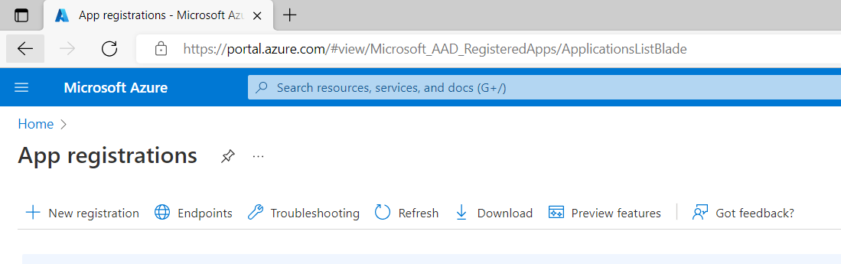

Post that below window will appear. Specify the Name for the application & then click on Register

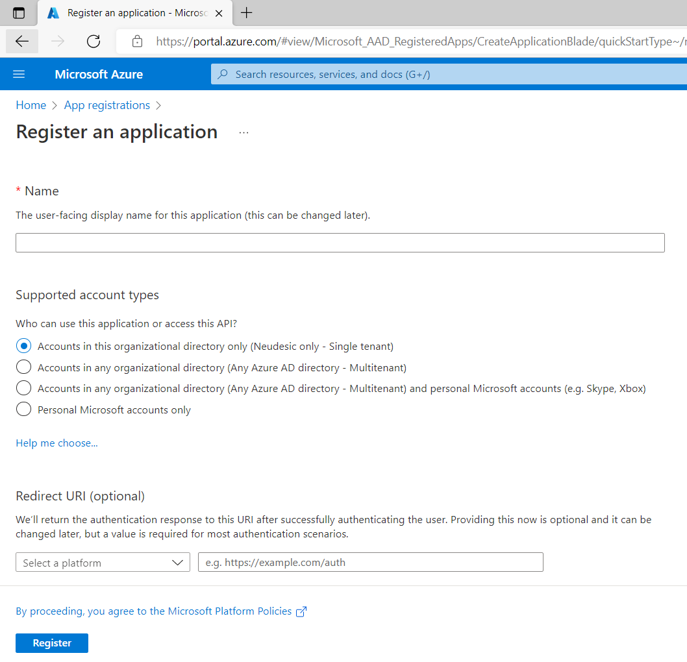

After creating application below window will appear then go to Certificates & secrets.

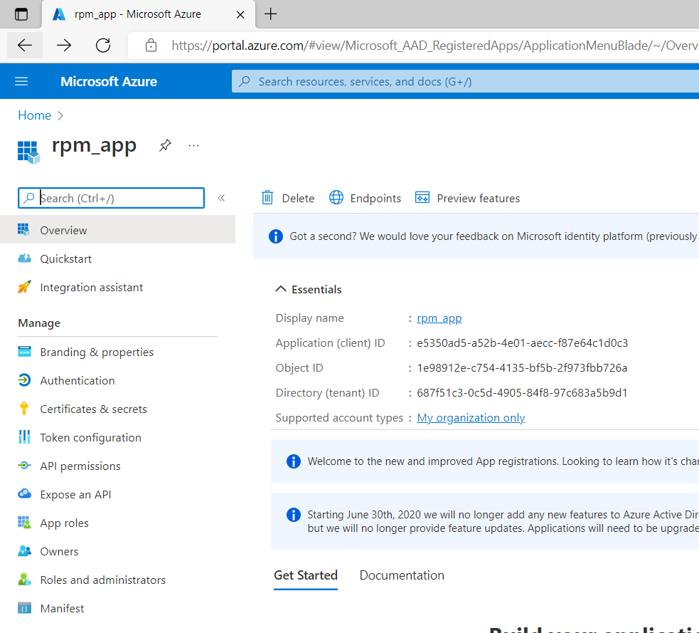

Go to Client secrets and to create client secret click on New client secret

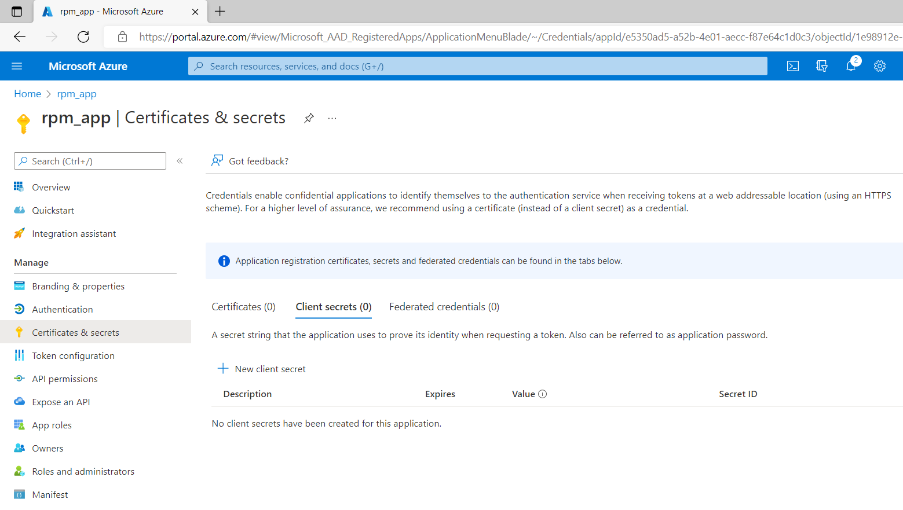

Below window will appear add description (name) and expiry details for secrets.

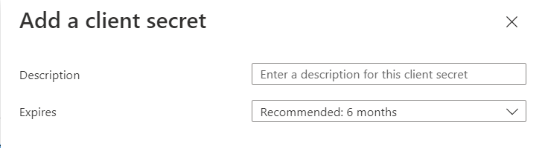

Post that below information will be available on the screen. Kindly make note of Value which will be required for further use.



1. Create a “Storage Account” -

Search for “Storage account” resource and open it which will open below screen

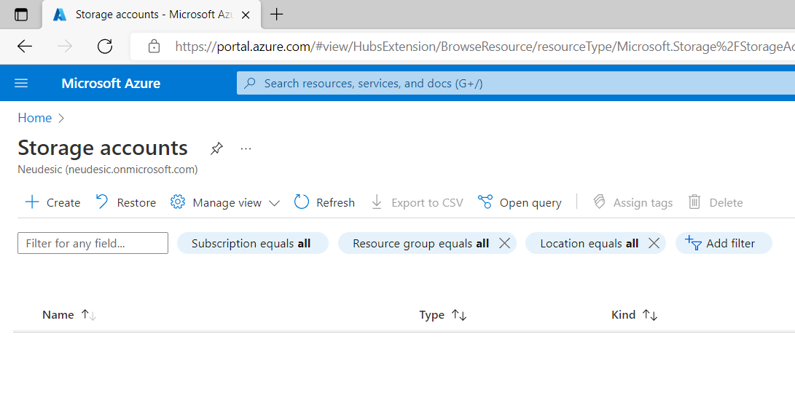

Click on Create which will open new screen for inputs for storage account as shown below

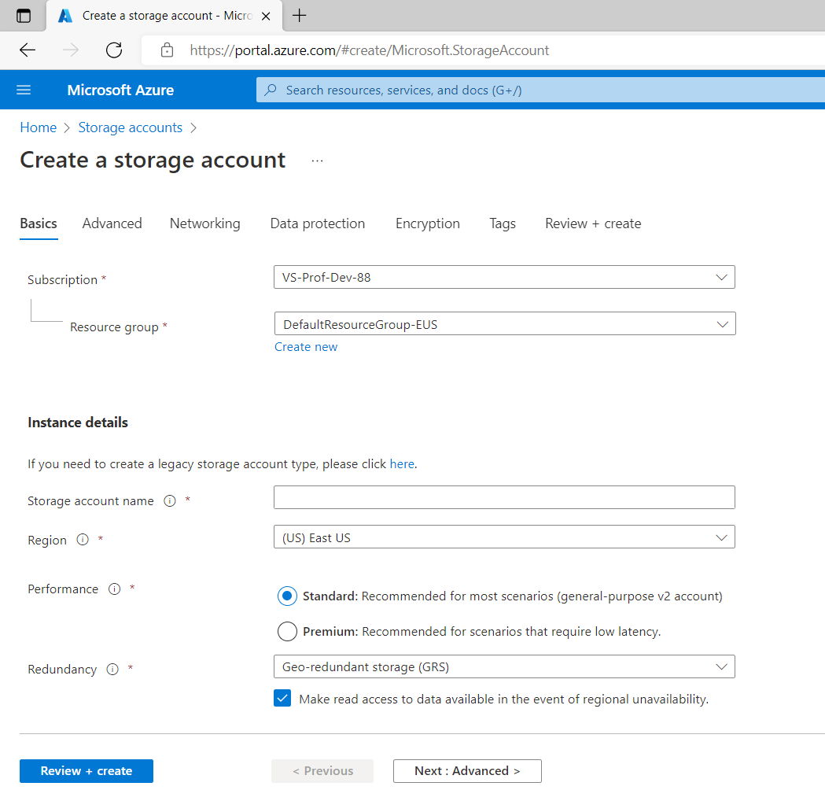

Specify the values for parameters like Subscription, resource group (created in step 1), storage account name, region & Redundancy (Locally Redundant Storage LRS) then click on Review + Create which will validate the details. Post validations click on create to complete the creation of Storage account.

After that search for the Storage account using name & open it then below screen will be opened.

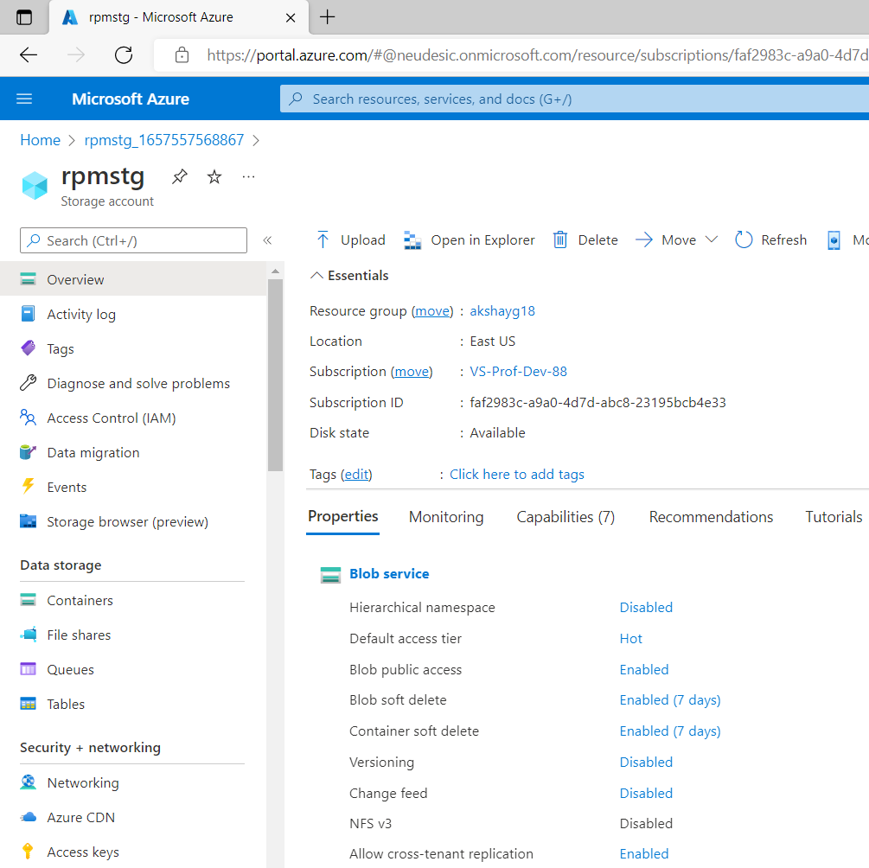

Go to Container section in left pane & click on Container (highlighted) to create a container.

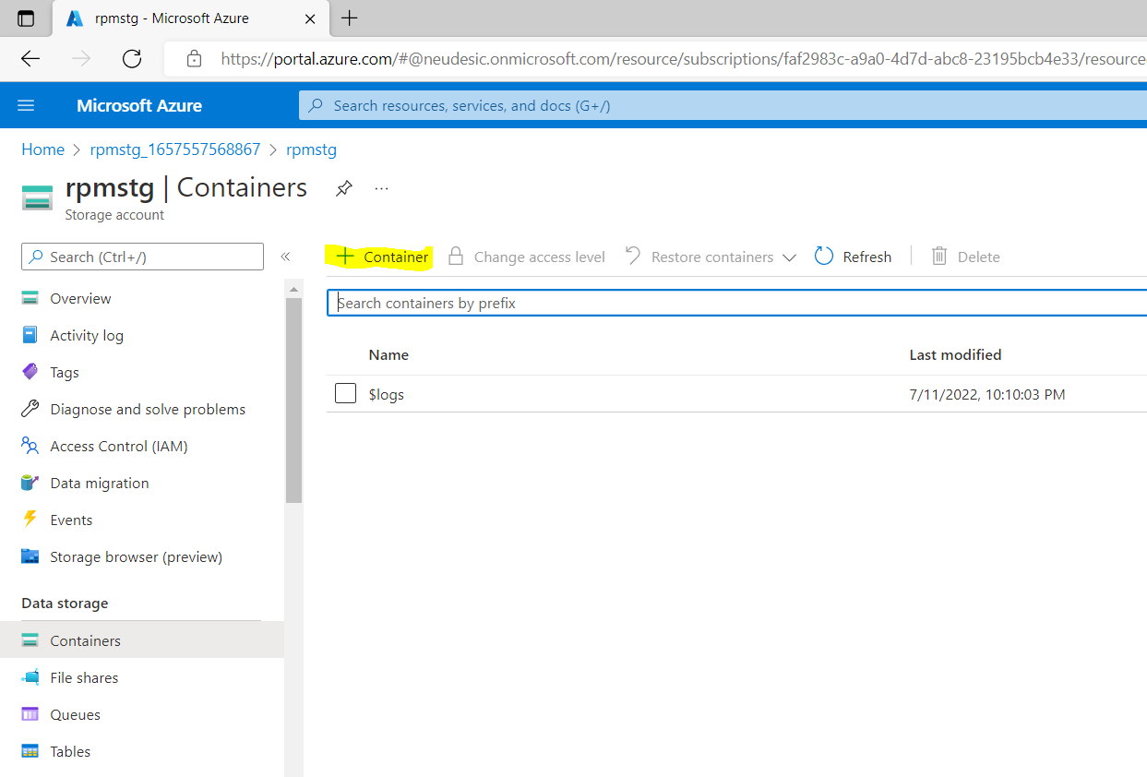

Below screen will appear then specify the name for the container & click on create button. It will create the container with specified name in the storage account.

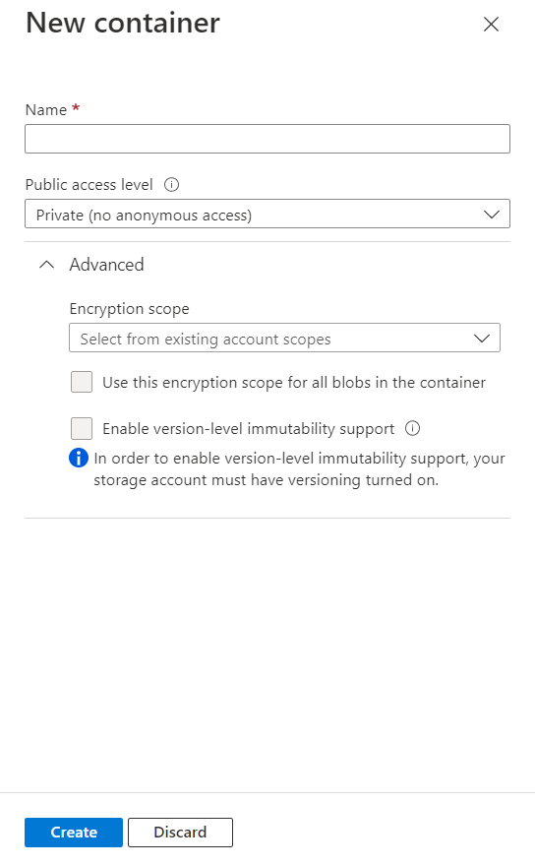

Post that open the “Access Control (IAM)” from left pane.

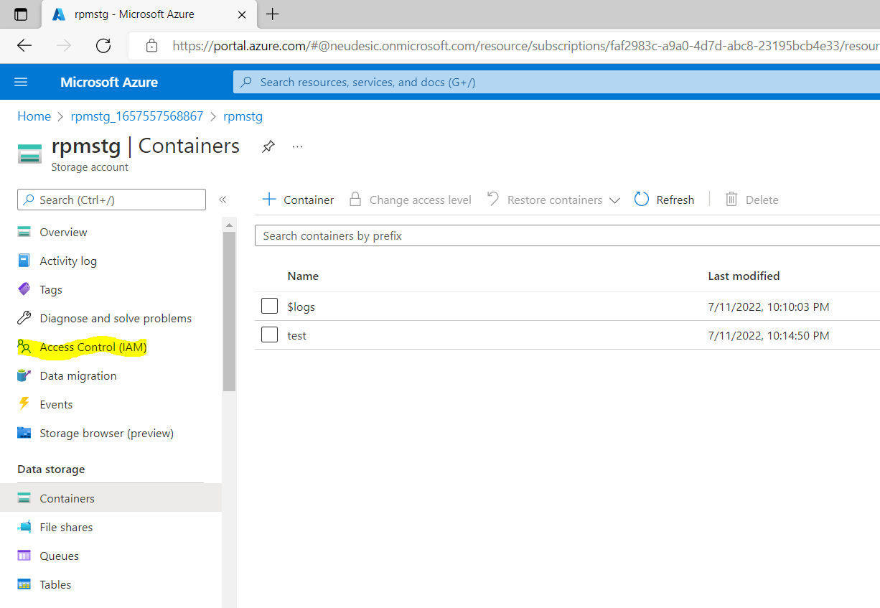

It will open below screen then click on “Add Role Assignment” (highlighted)

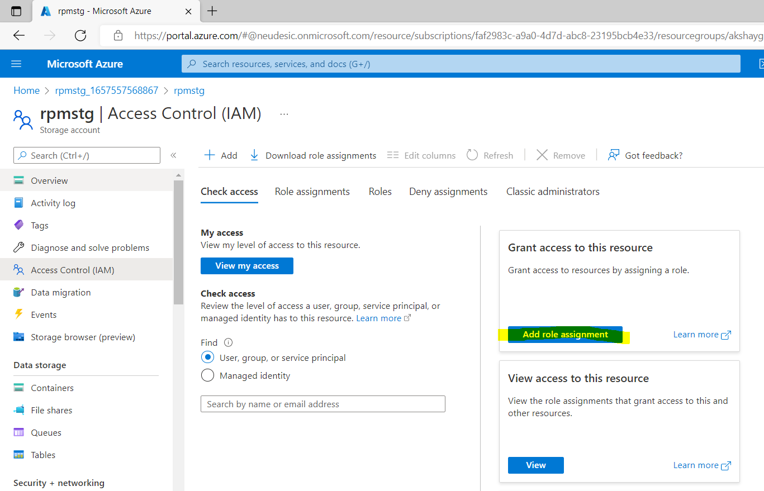

It will open below screen. Search for the “Storage Blob Contributor” role & click on role followed by next button.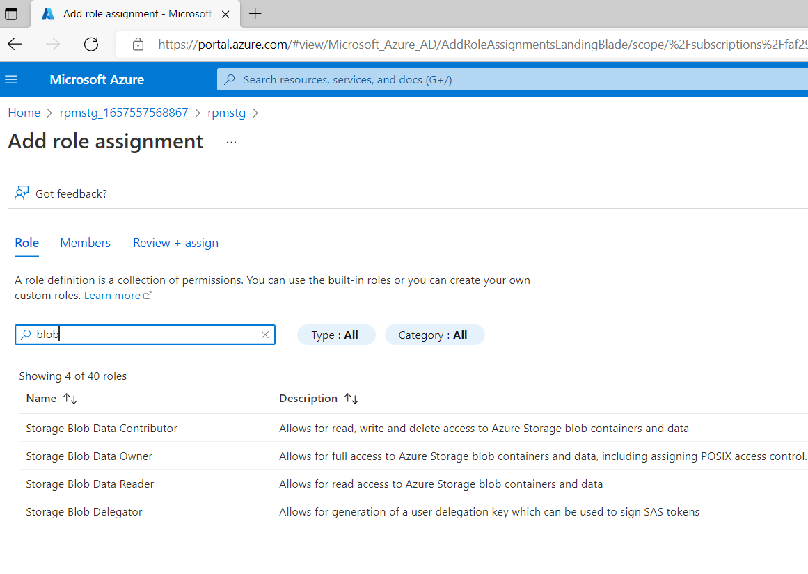Post that below screen will appear then click on select member (highlighted)

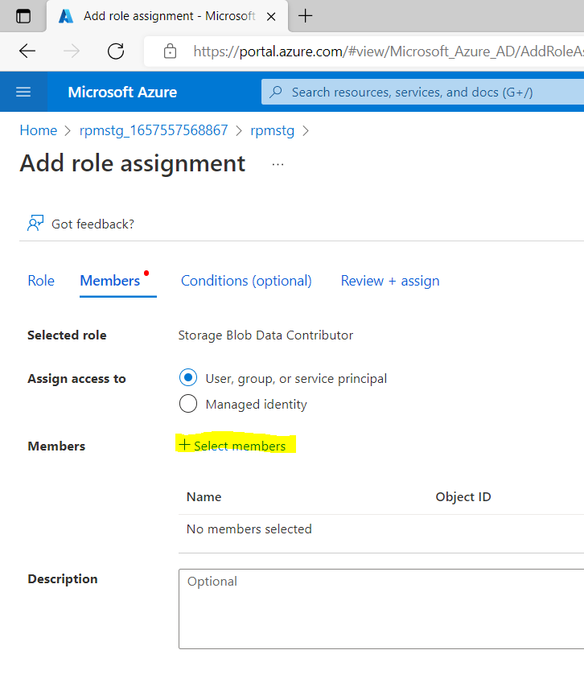

In below screen search for the “App registration” resource created in step 2 & click on Select. After that click on Review & Assign button.

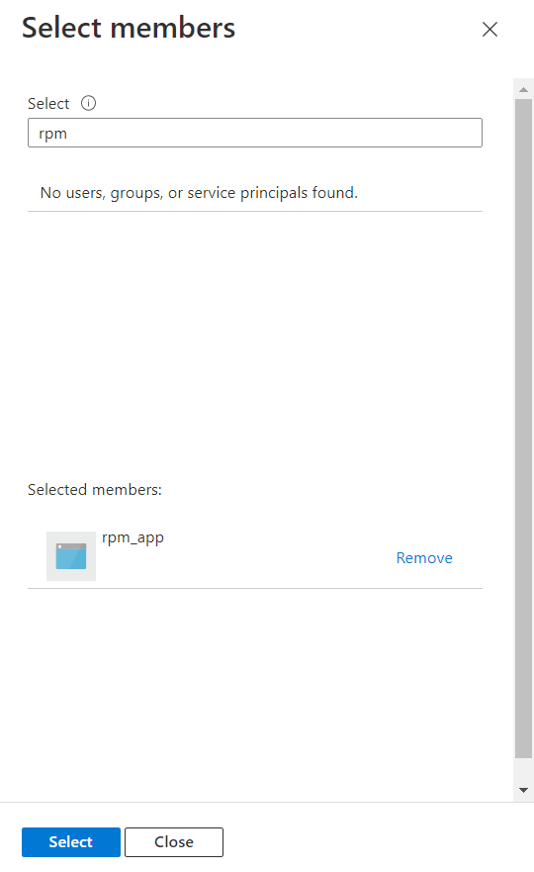

1. Create a “Azure Databrics” –

Search for “Azure Databrics” resource and open it which will open below screen & then click on Create button (highlighted)

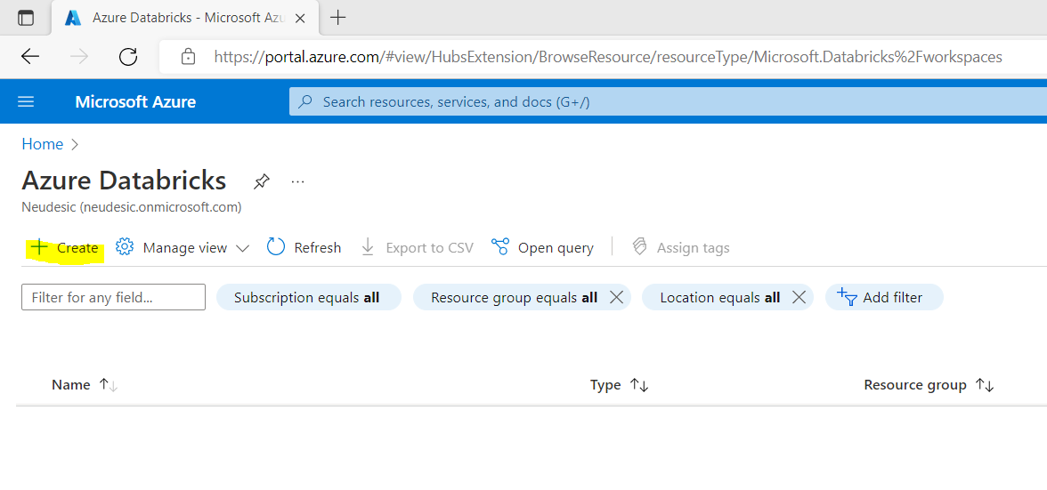

After that below screen will appear then specify the parameters like Subscription, Resource Group (created in Step 1), Workspace Name, Region & Pricing Tier then click on Review + Create which will validate the details. Post validations click on create to complete the Azure Databricks creation

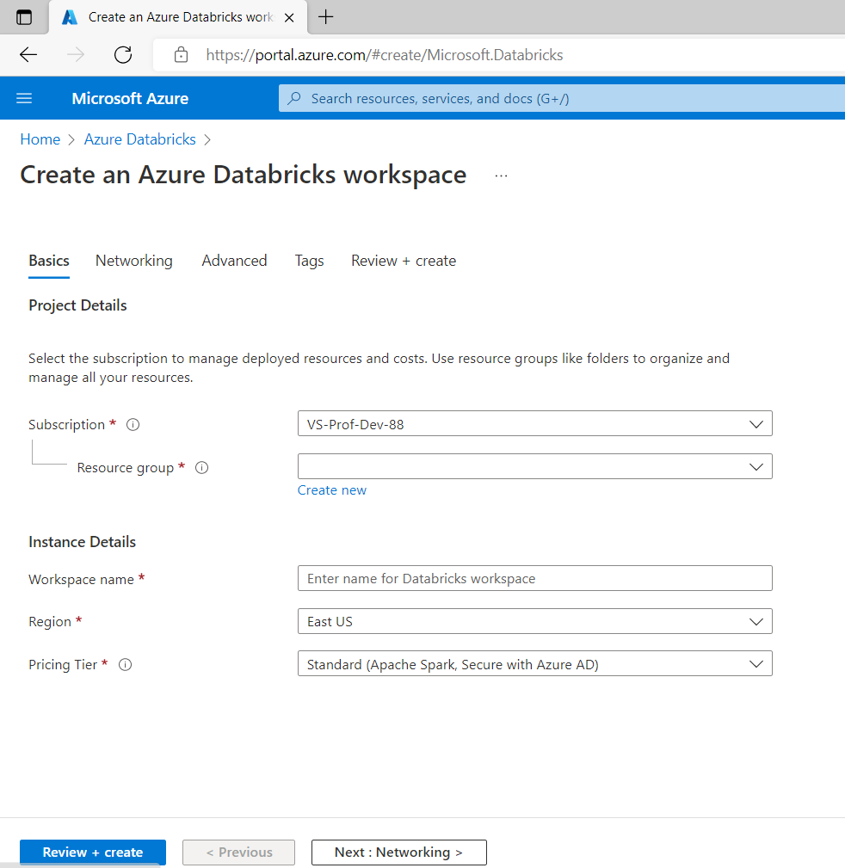

Below screen will appear then click on Go to resource.

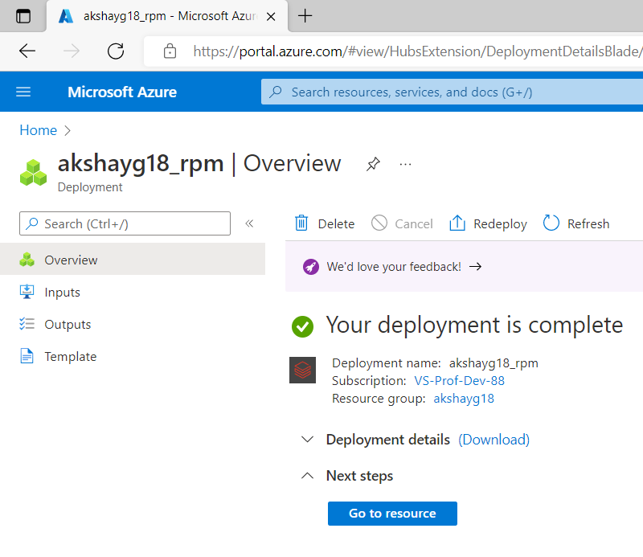

After above activity below screen will appear. Click on Launch Workspace.

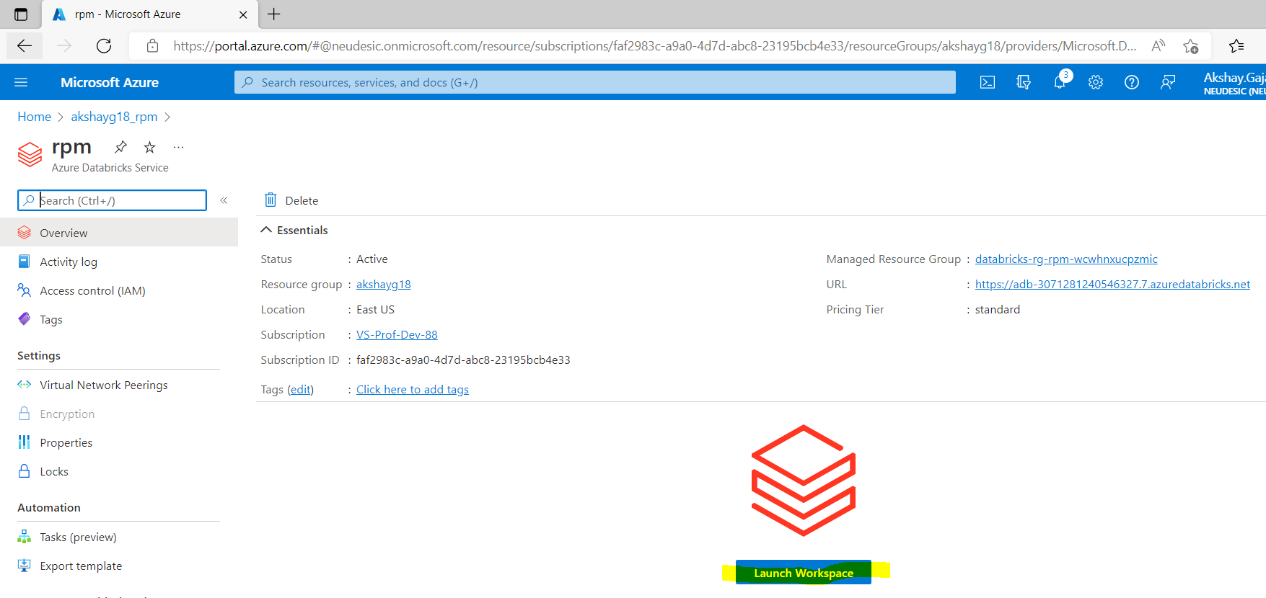

It will open Databricks workspace in new window. Then click on “Create a cluster”.

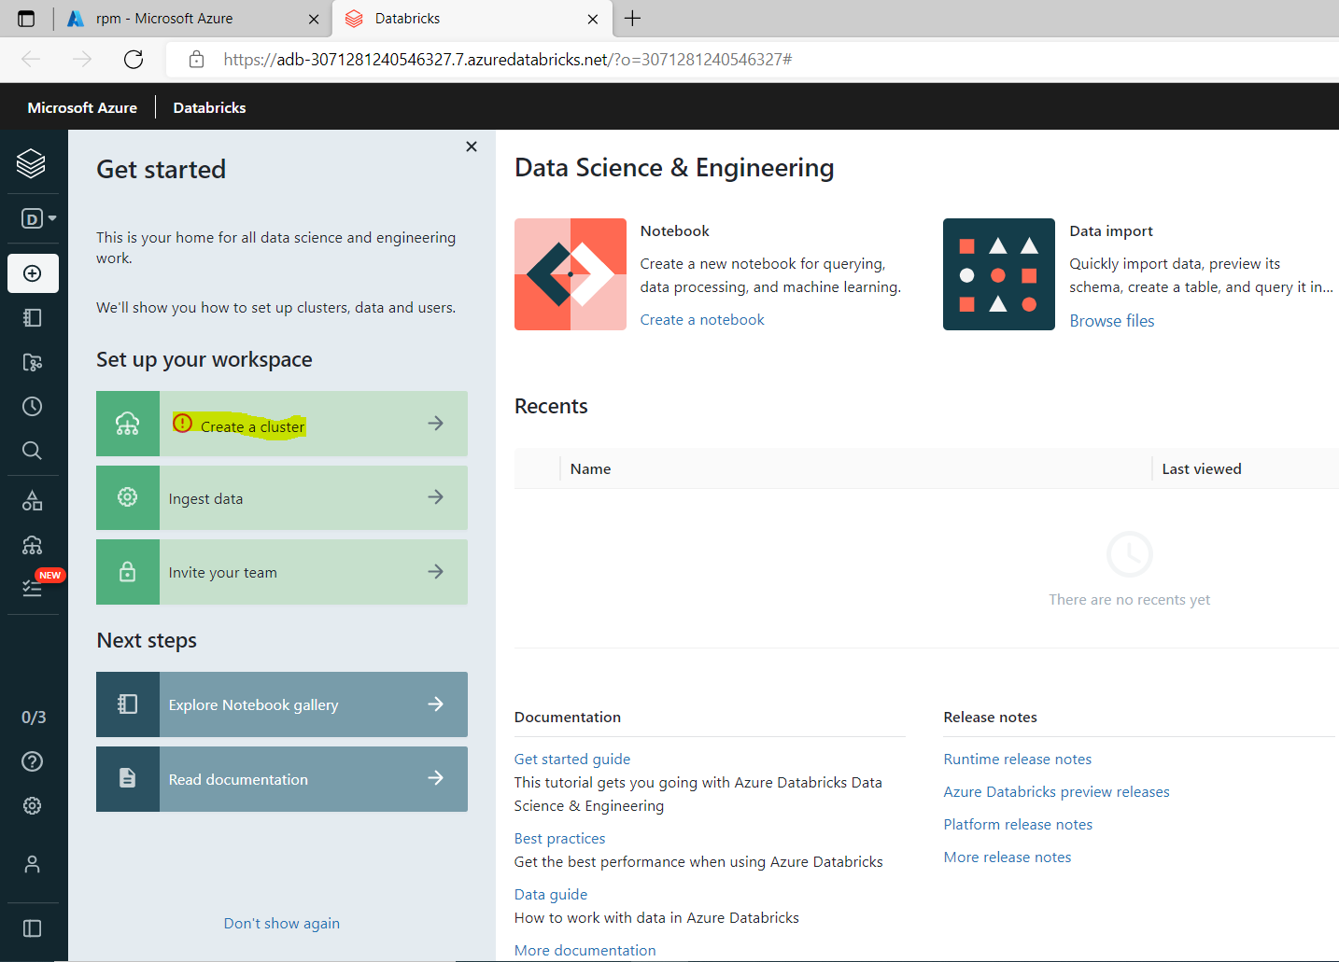

It will open below screen then click on Create Cluster button.

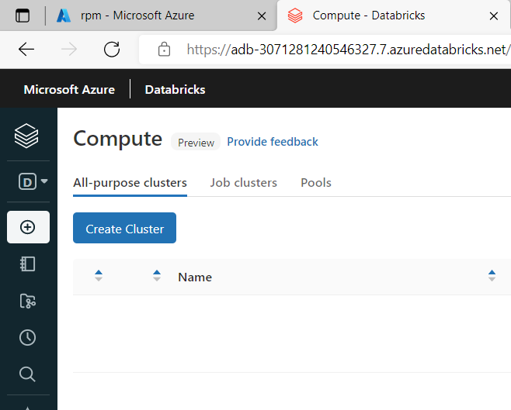

It will open below screen then specify the details like Cluster Name, terminate after 30 minutes of inactivity & leave rest details to default.

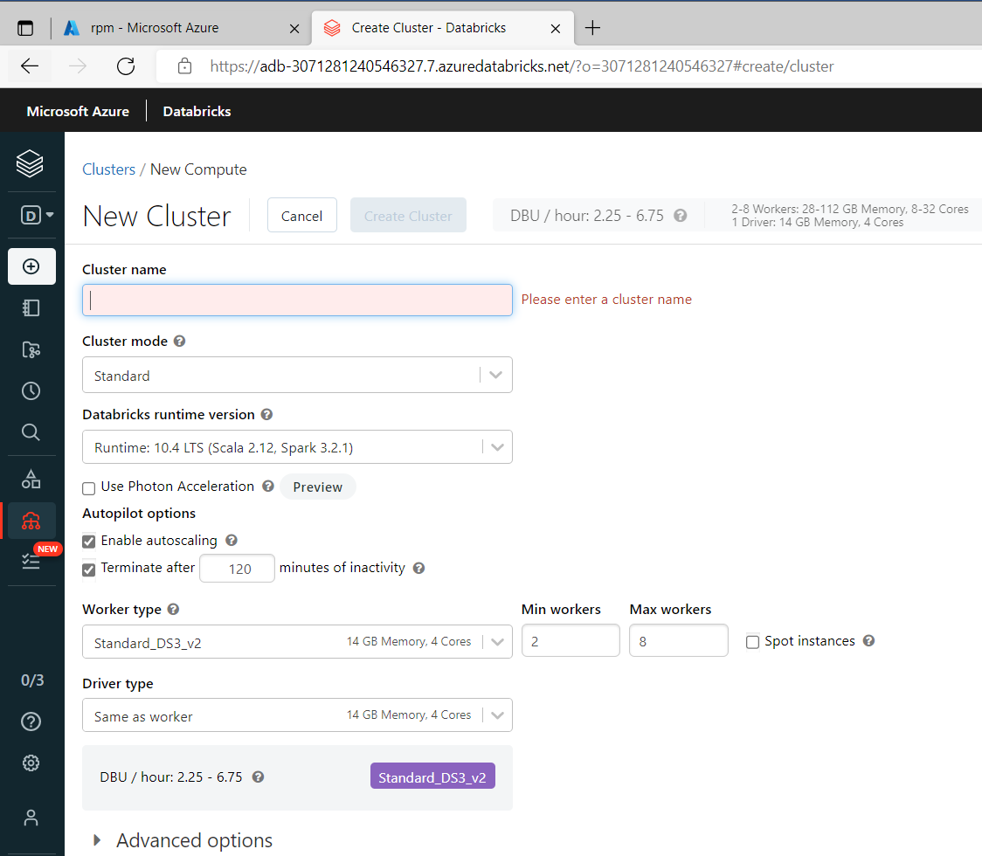

Post successful creation of cluster below screen will appear. Go to Libraries

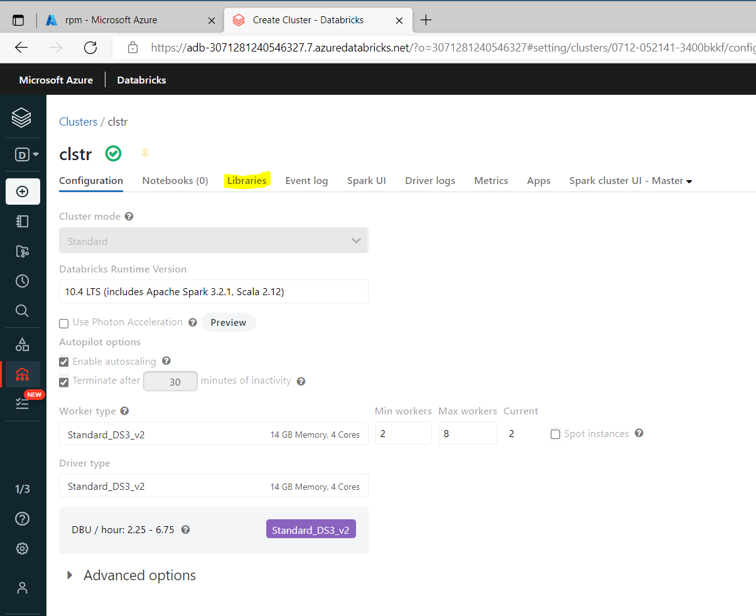

After that click on Install New

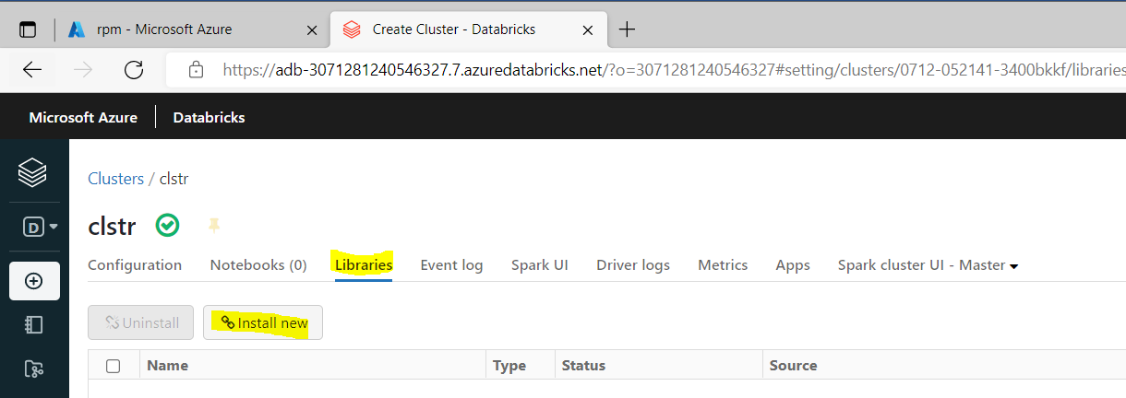

It will open below screen then select Maven as Library source

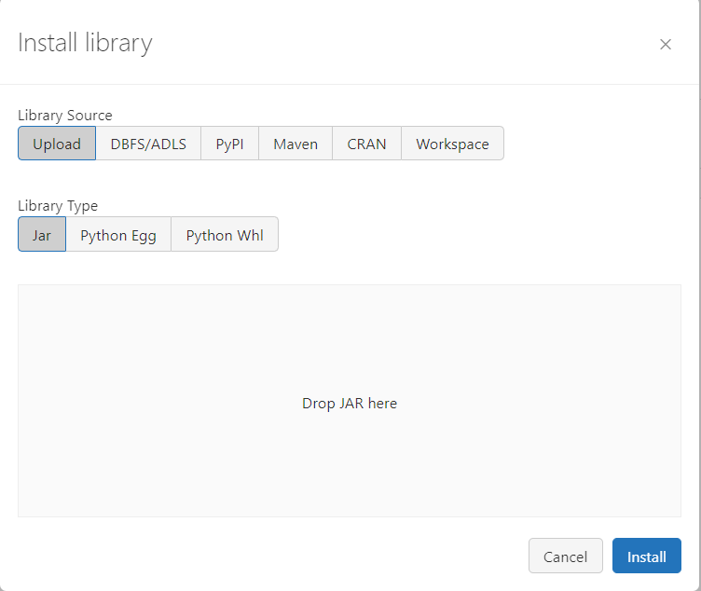

Then click on Search Packages

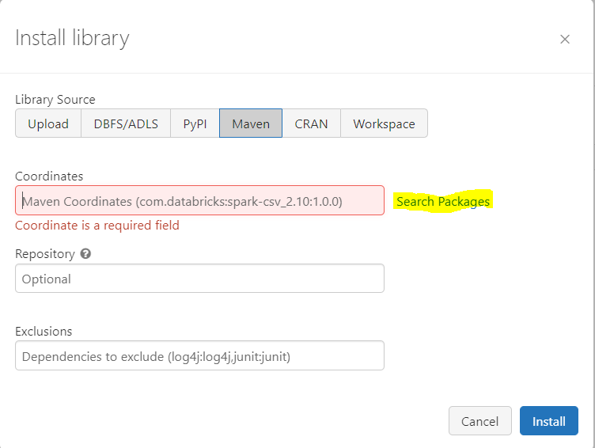

Select Maven Central in highlighted area and search for below packages in search bix & then click on Select

* 1. azure-cosmos-spark
  2. azure-eventhubs-spark

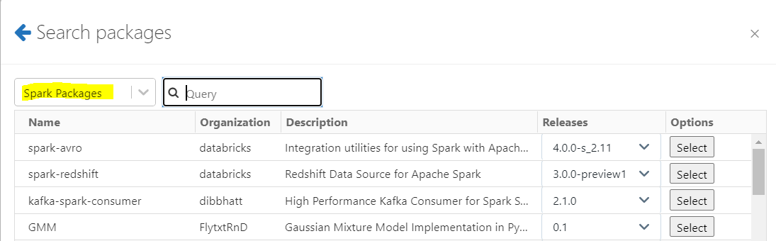

After that click on Install to completed library installation.

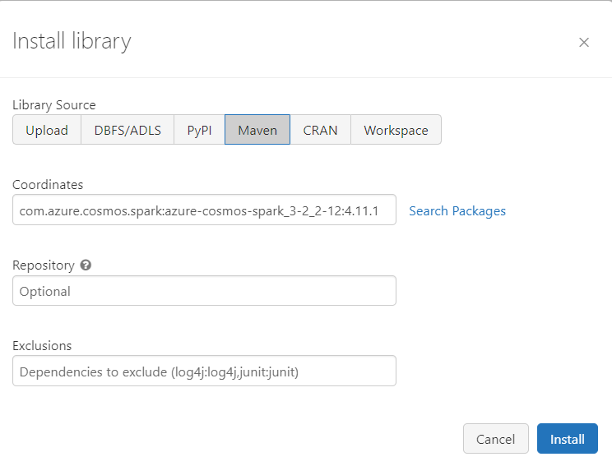

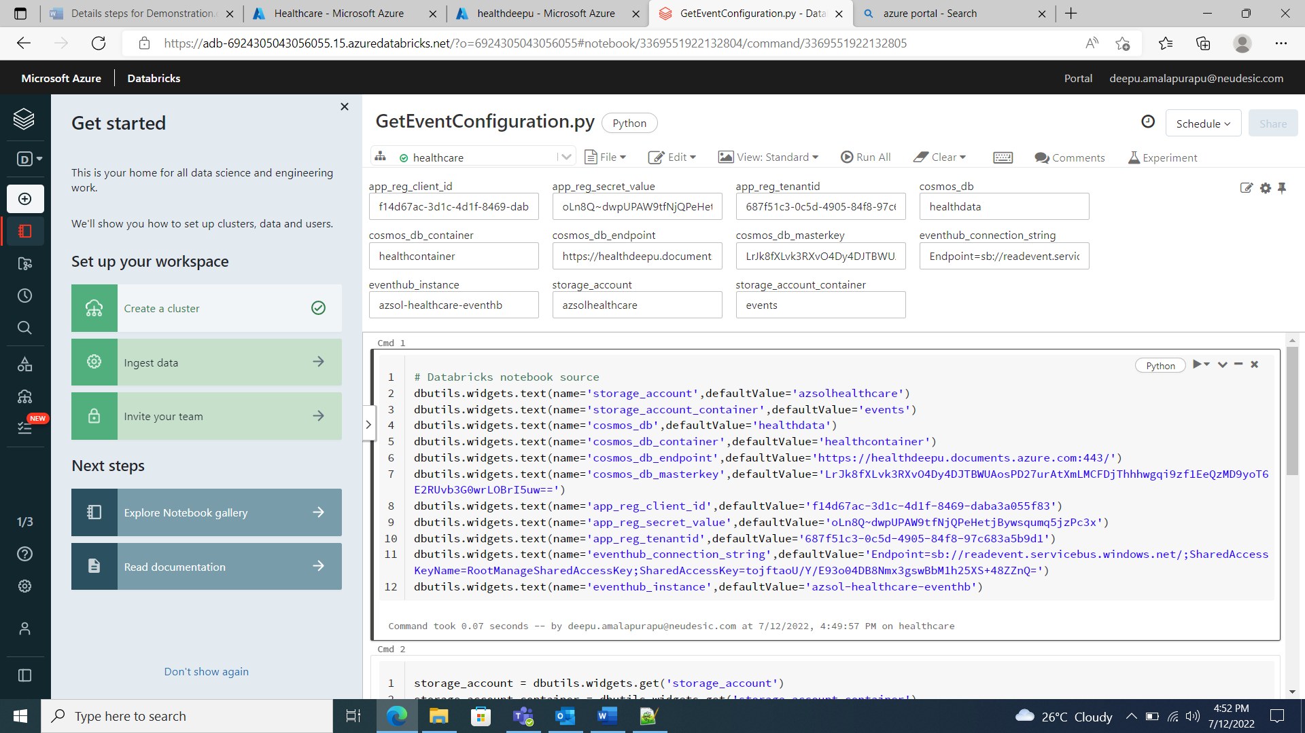

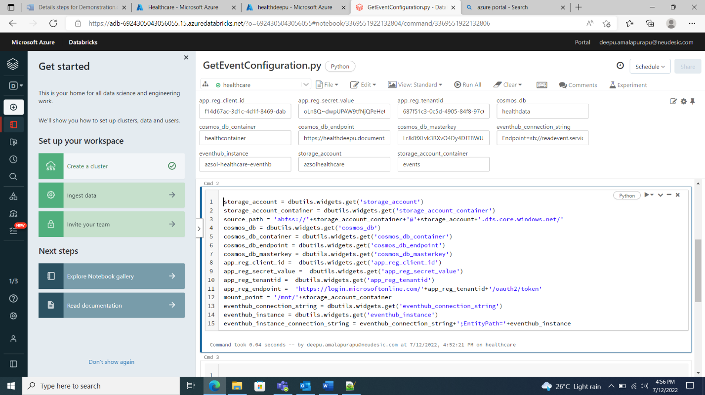

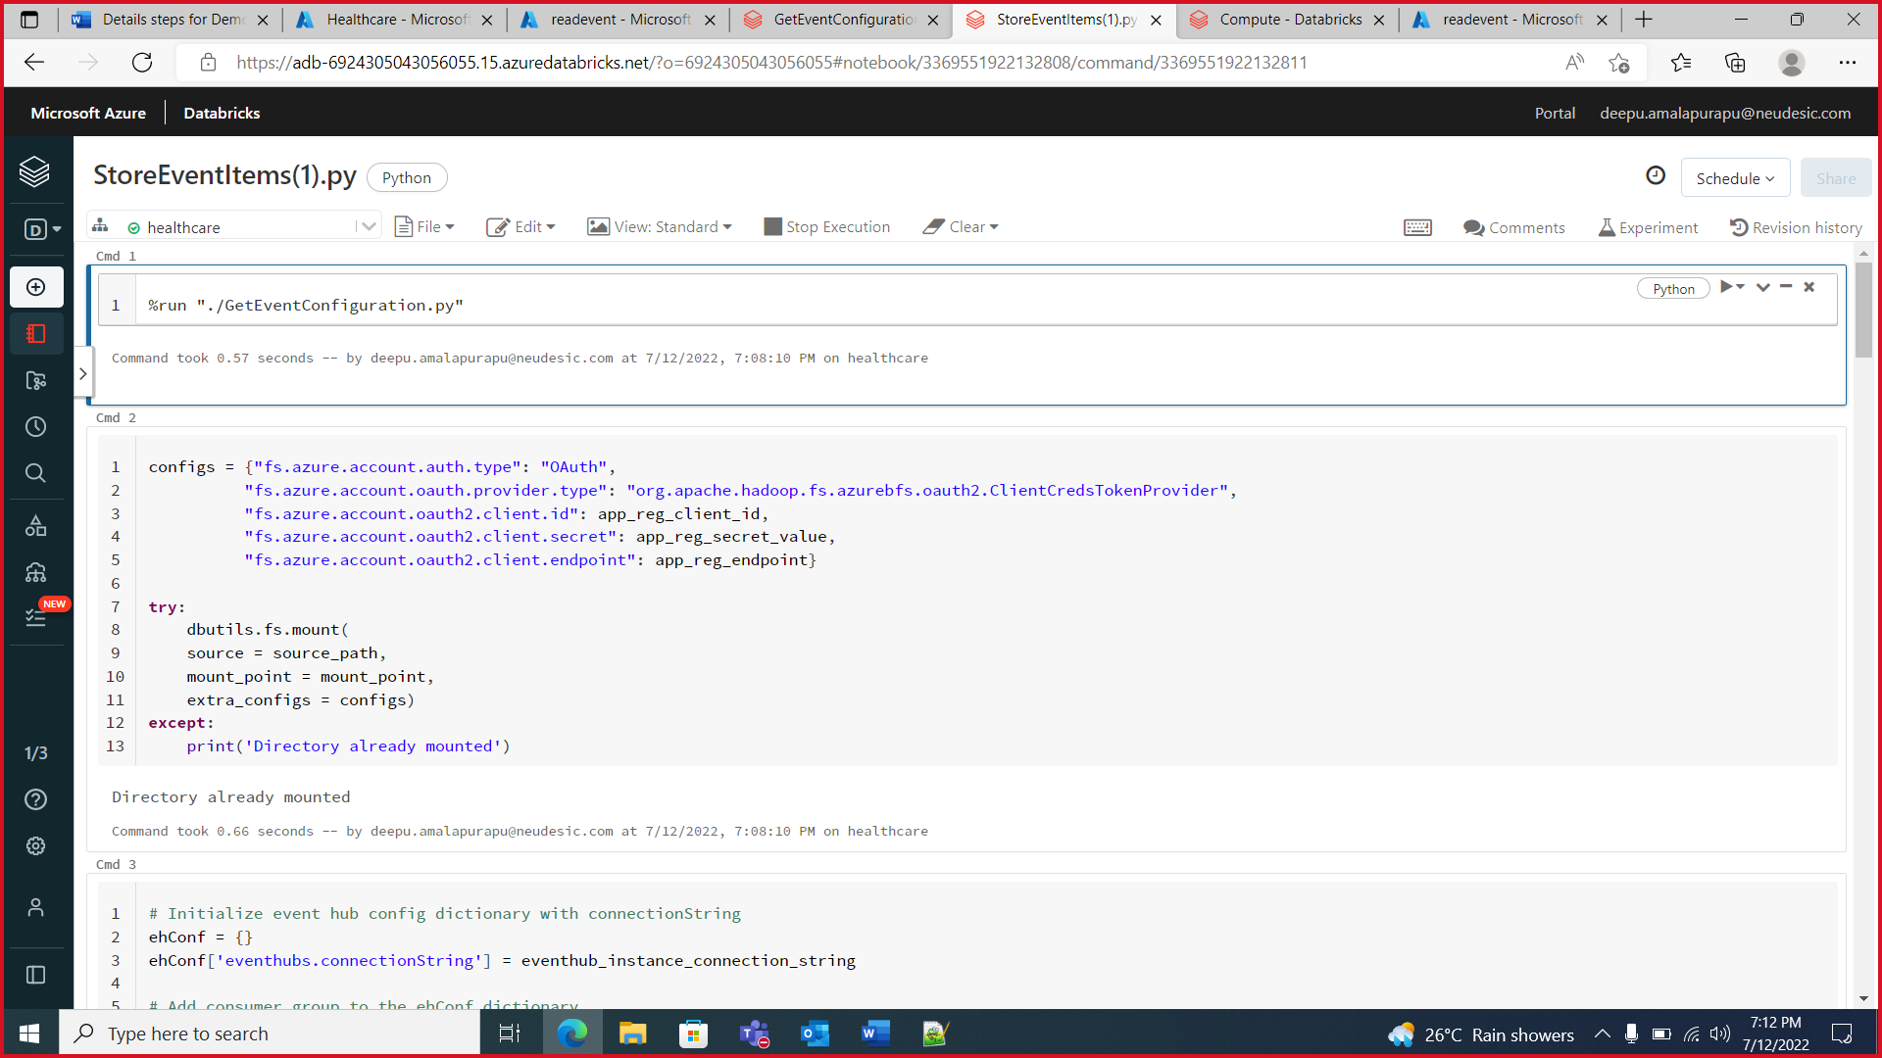

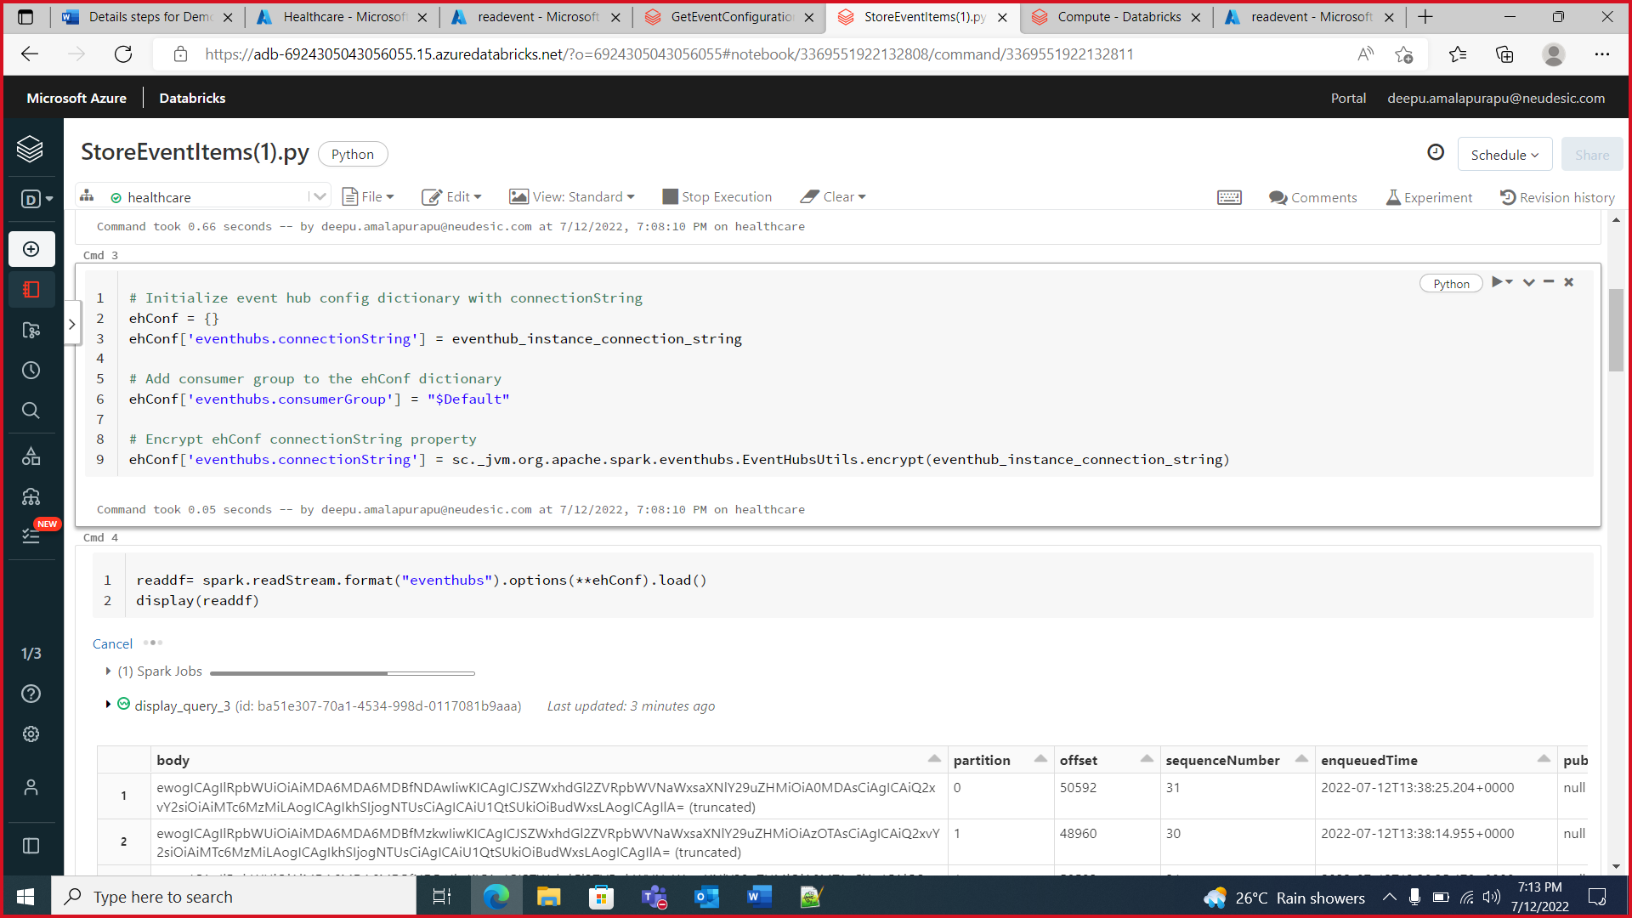

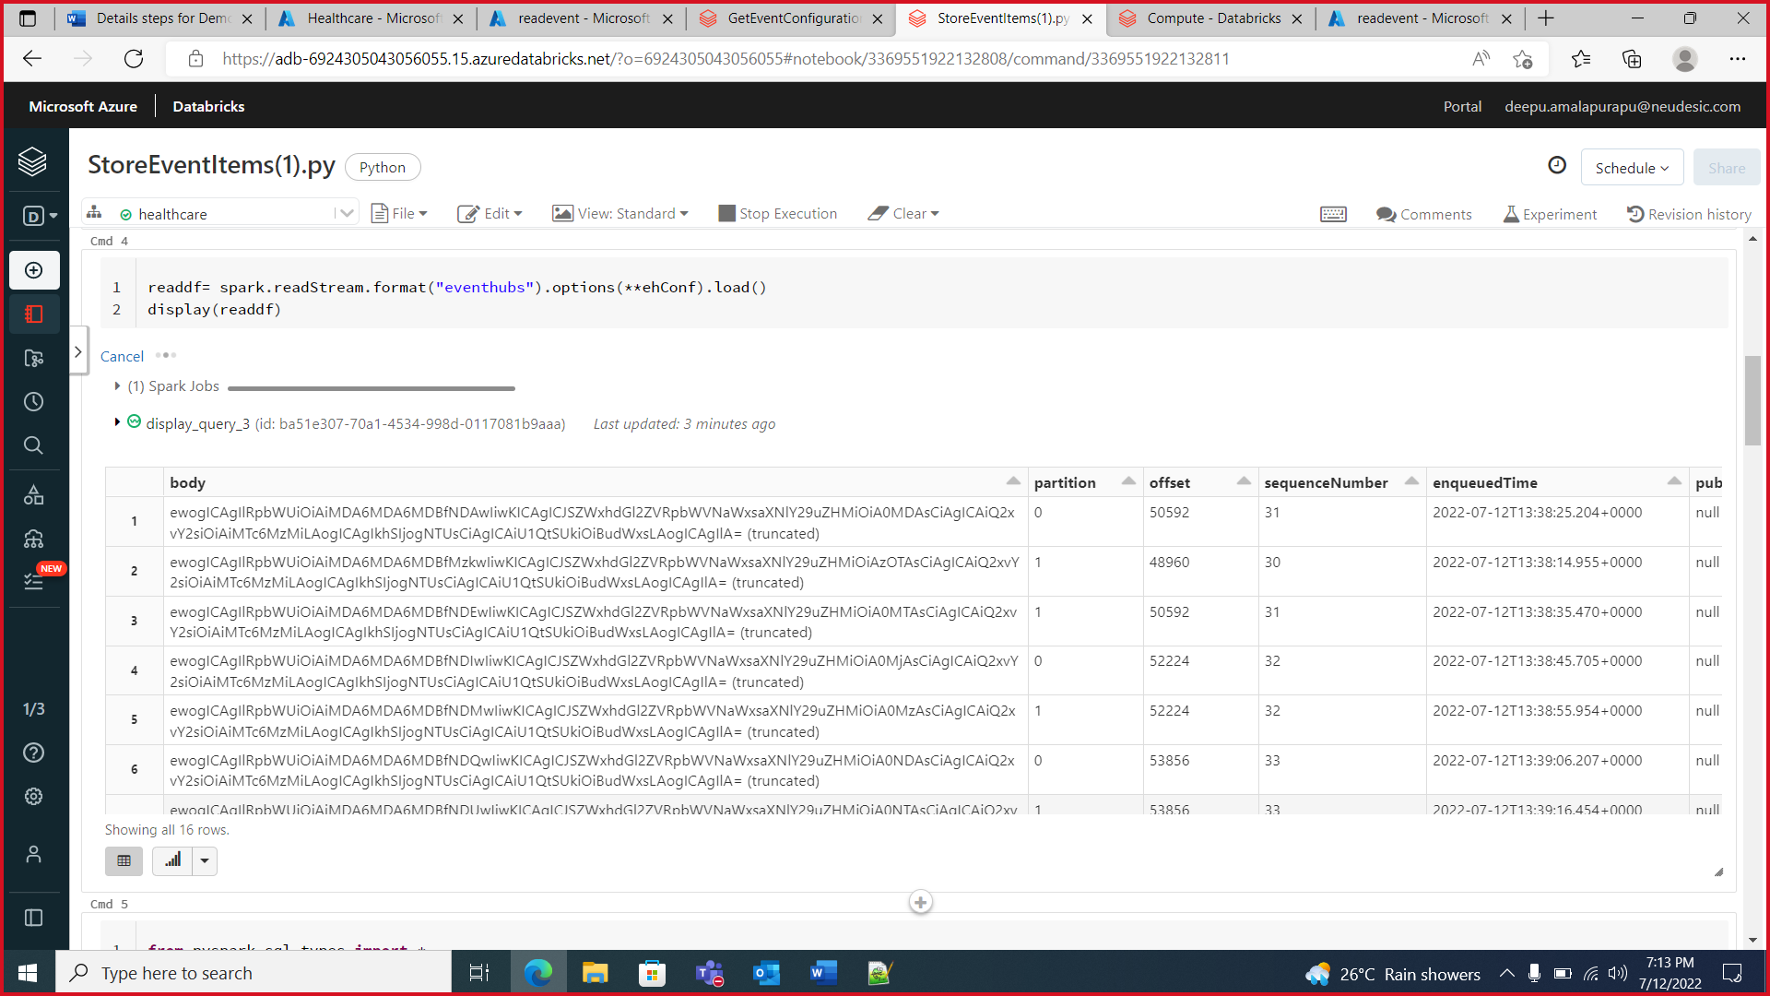

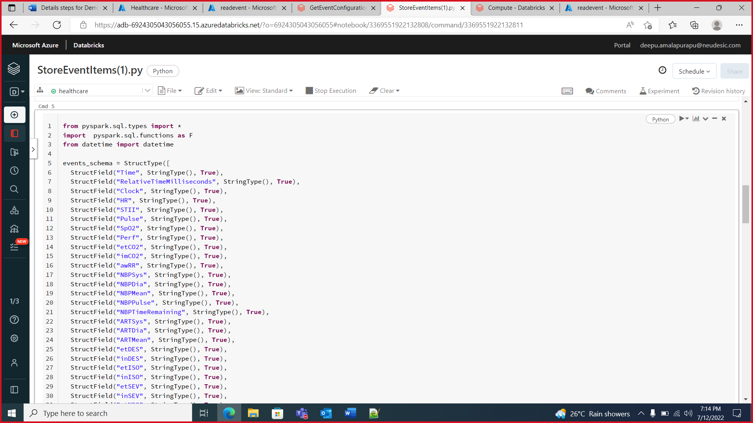

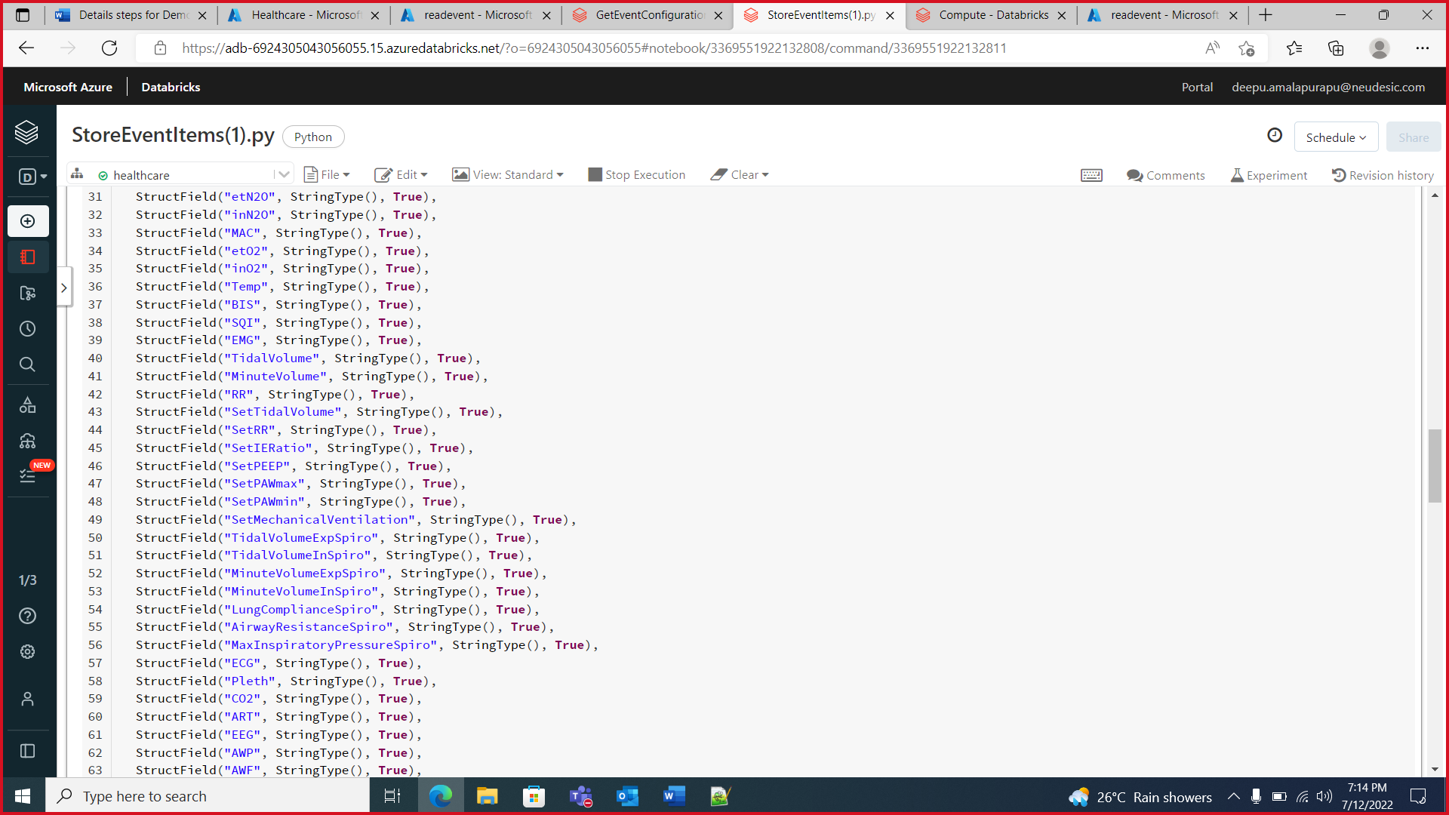

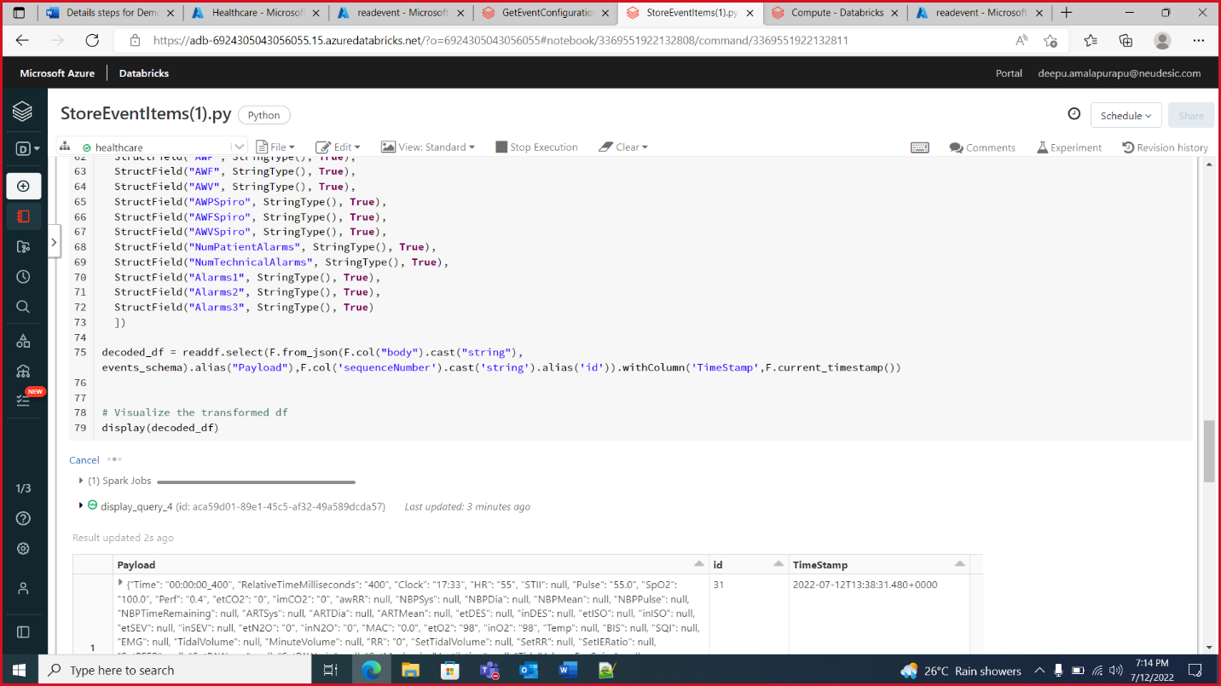

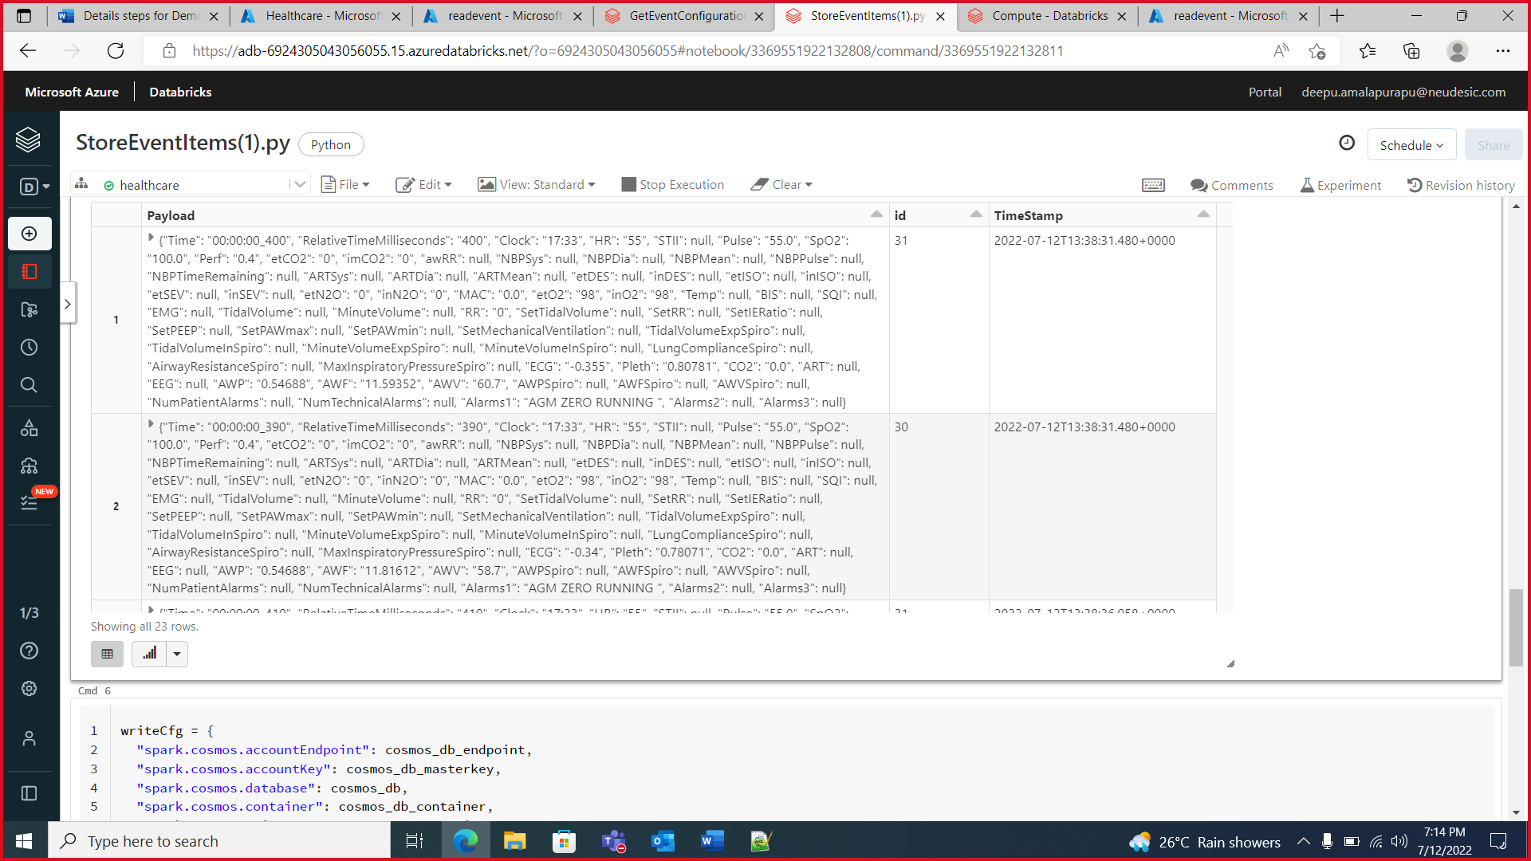

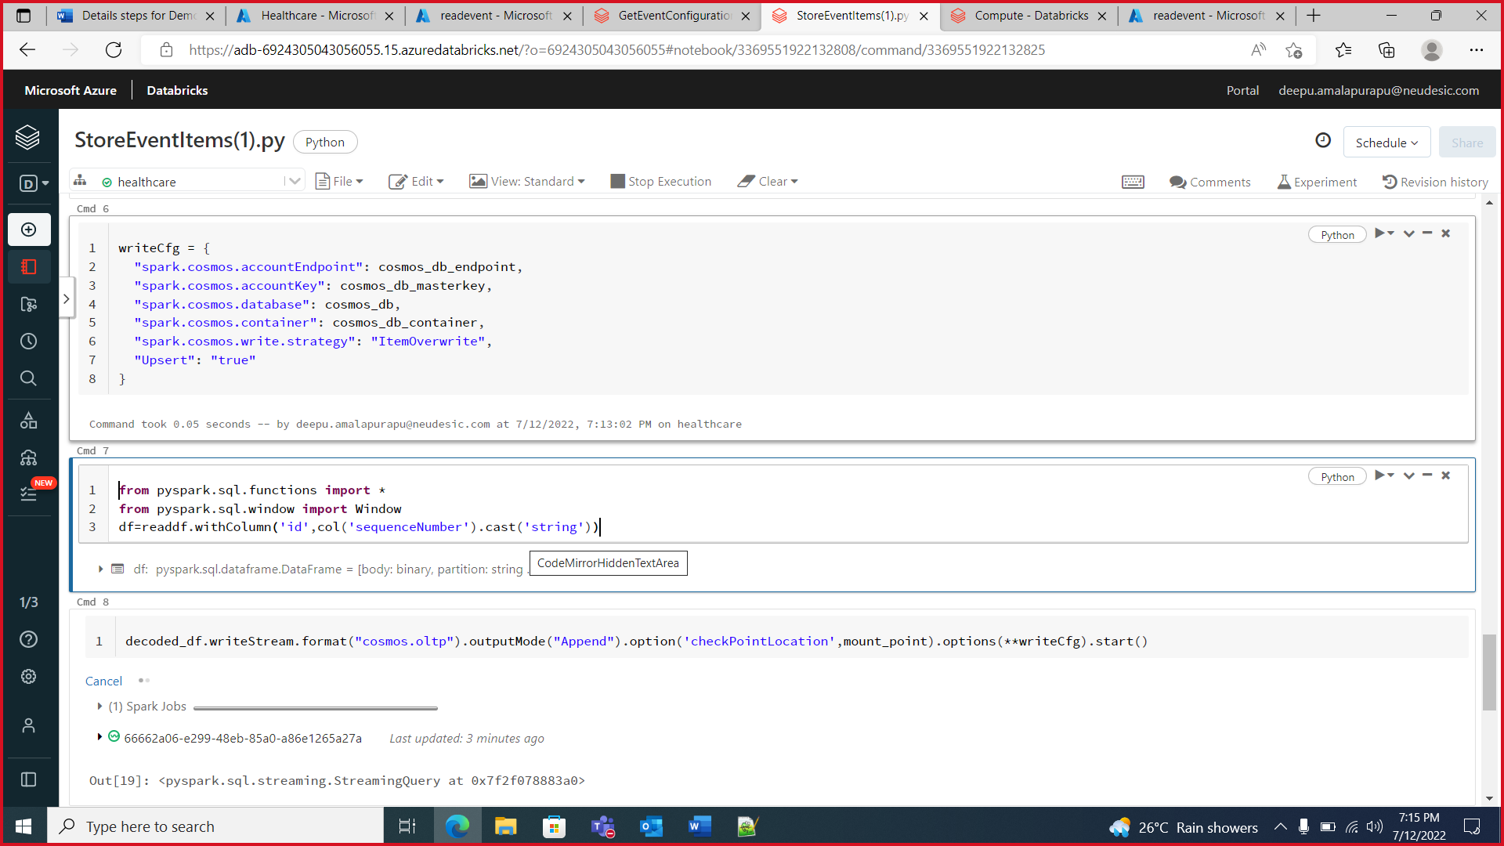

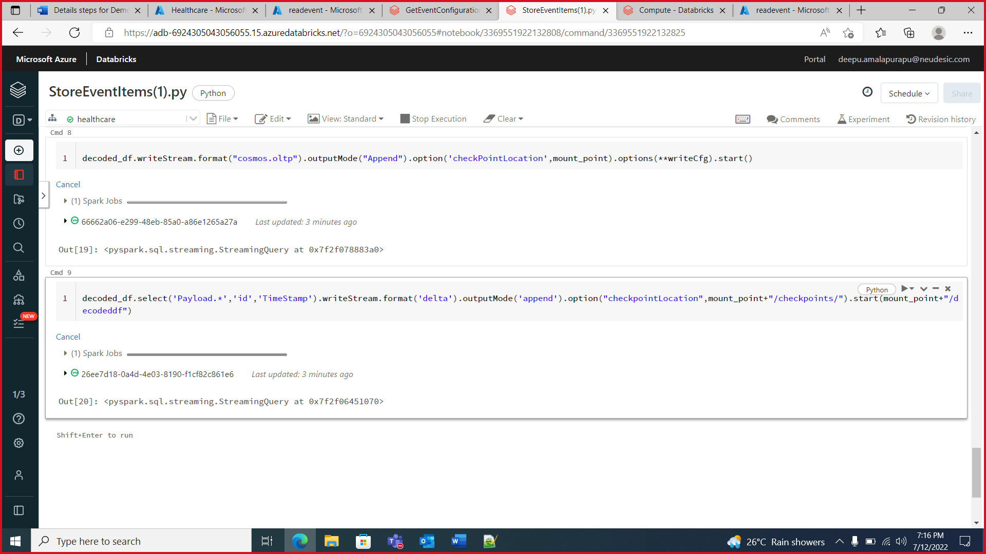

1. Create a “Event Hubs” –

Search for “Event Hubs” resource and open it which will open below screen & then click on Create button (highlighted)

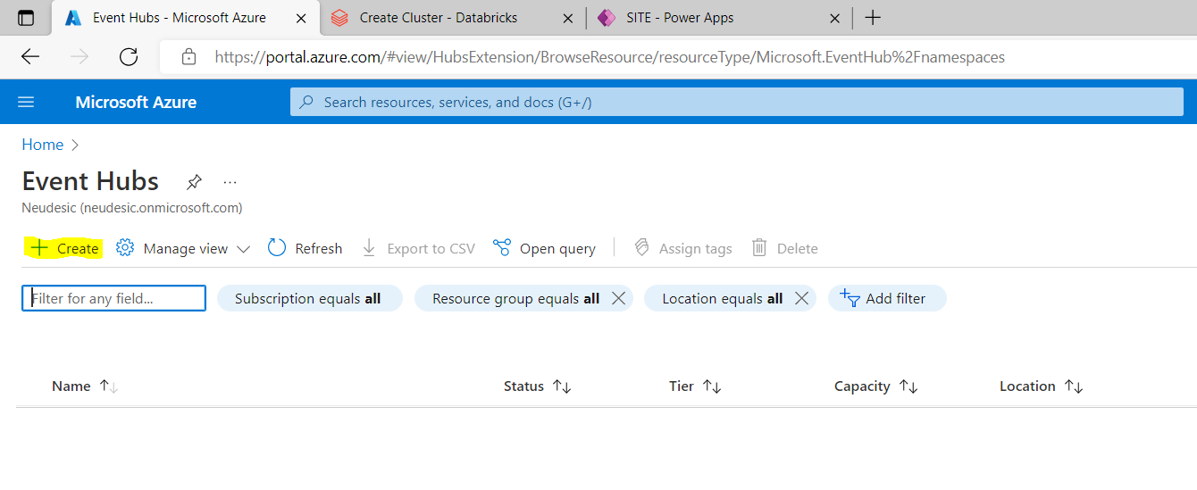

It will open below screen then specify the details like Subscription, Resource Group (created in step 1), Namespace Name, location, Pricing tier (Basic) & leave rest details to default then click on Review + Create which will validate the details.

Post validations click on create to complete the resource group creation.

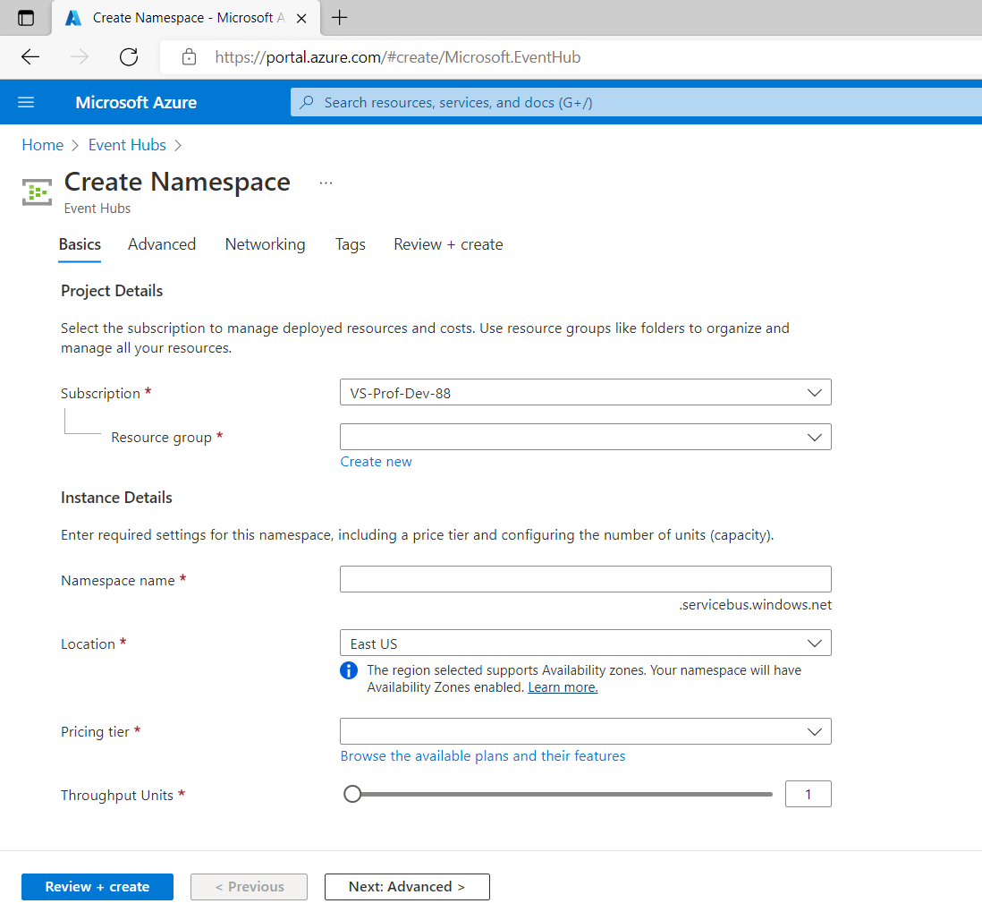

Below screen will appear then click on Go to resource.

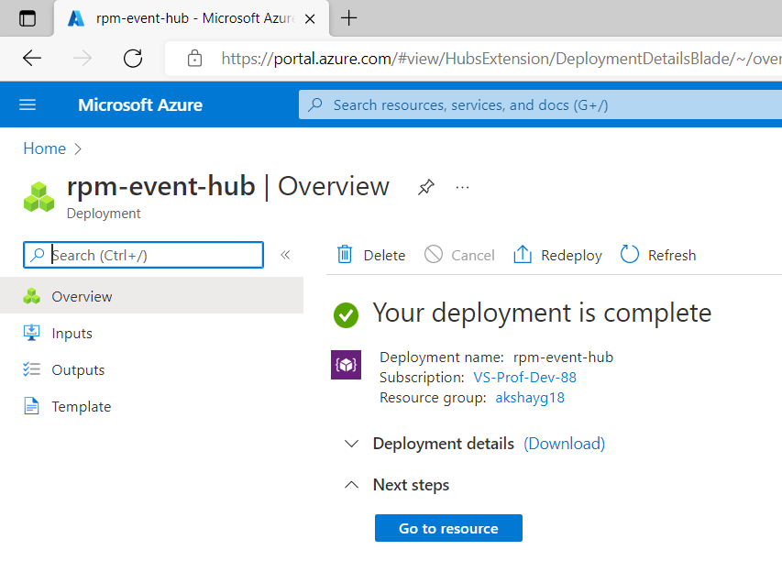

After that below screen will appear. Click on Event Hubs (highlighted)

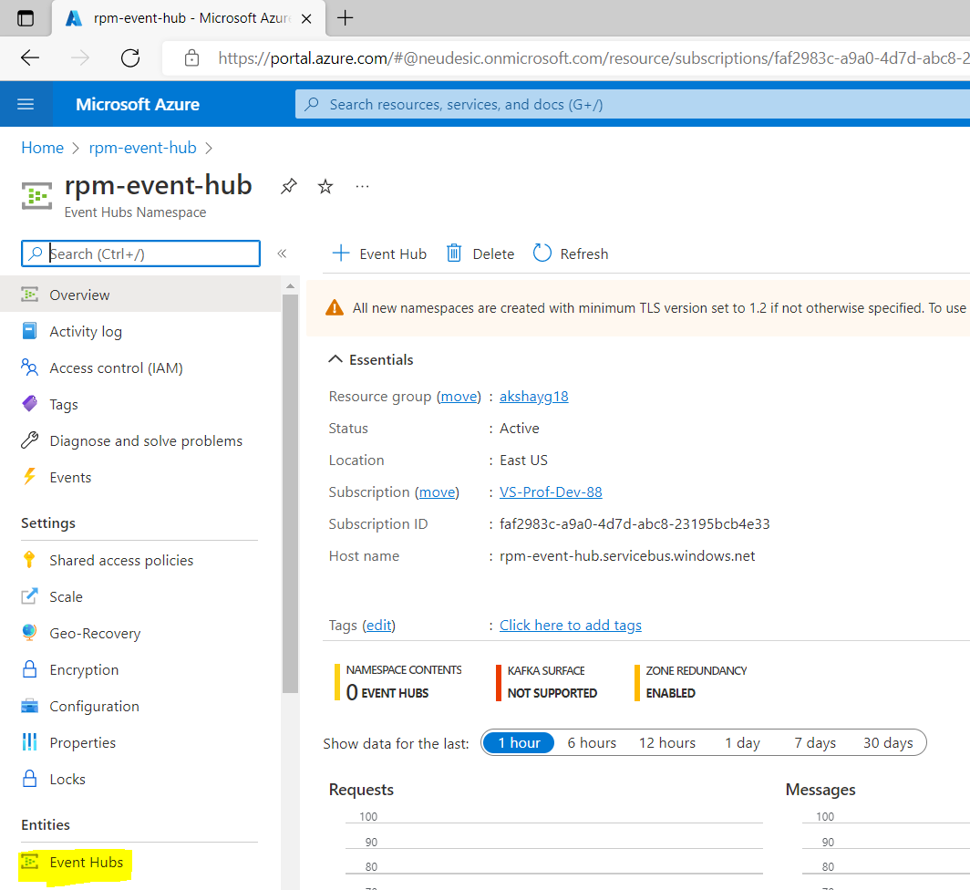

It will open below screen then click on Event Hub (highlighted) to create an instance.

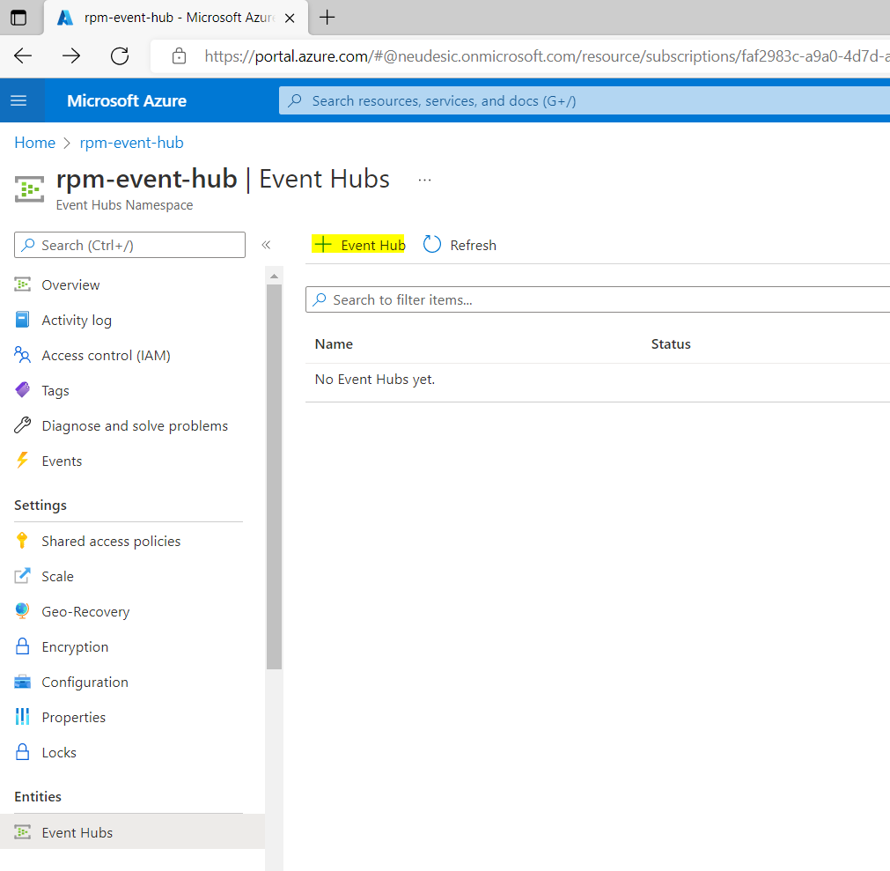

Below screen will appear then specify the name for the event hub instance & keep rest details default then click on Review + create button. It will create the event hub instance with specified name. which will validate the details. Post validations click on create. It will create event hub.

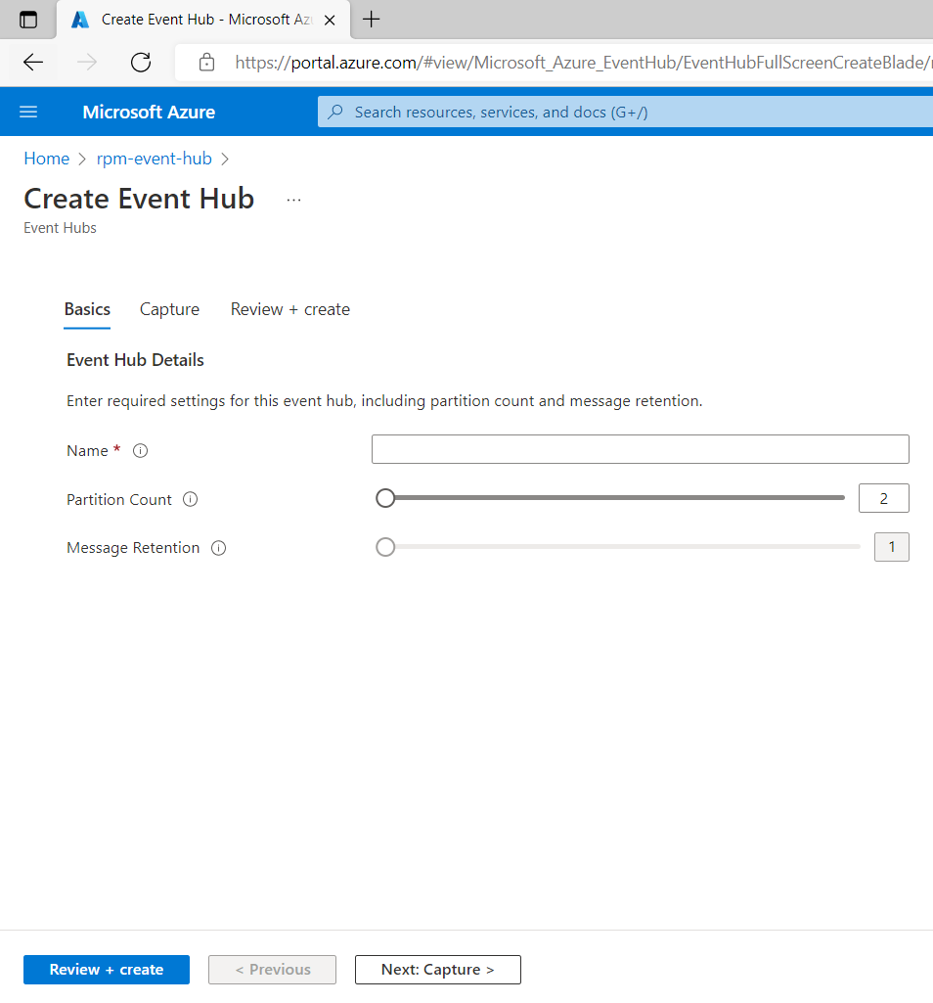

1. Create a “Cosmos DB Account” –

Search for “Azure Cosmos DB” resource and open it which will open below screen & then click on Create button (highlighted)

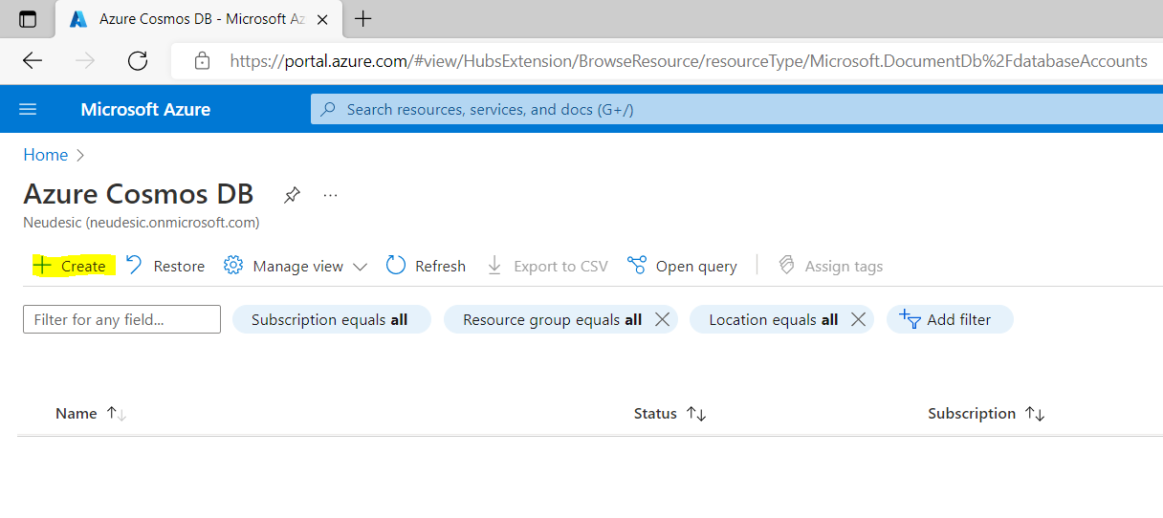

Below screen will appear click on create button for Core (SQL) – Recommended (as highlighted)

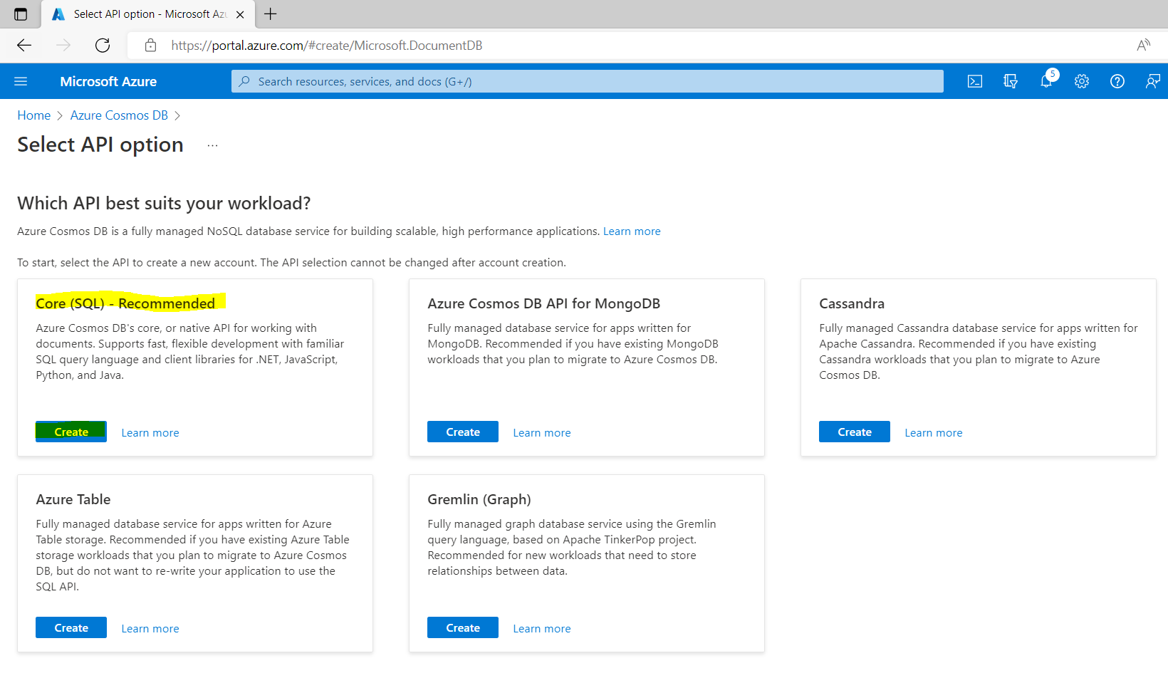

It will open below screen then specify the details like Subscription, Resource Group (created in step 1), Account Name, location then go to Backup Policy (highlighted)

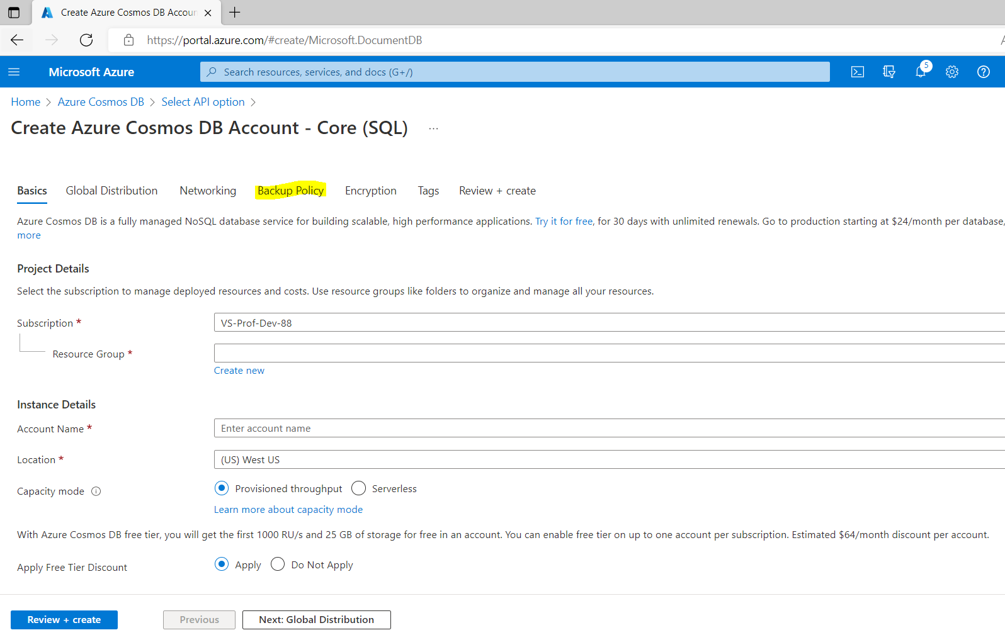

Select Locally redundant backup storage & leave rest details to default then click on Review + Create which will validate the details. Post validations click on create to finish.

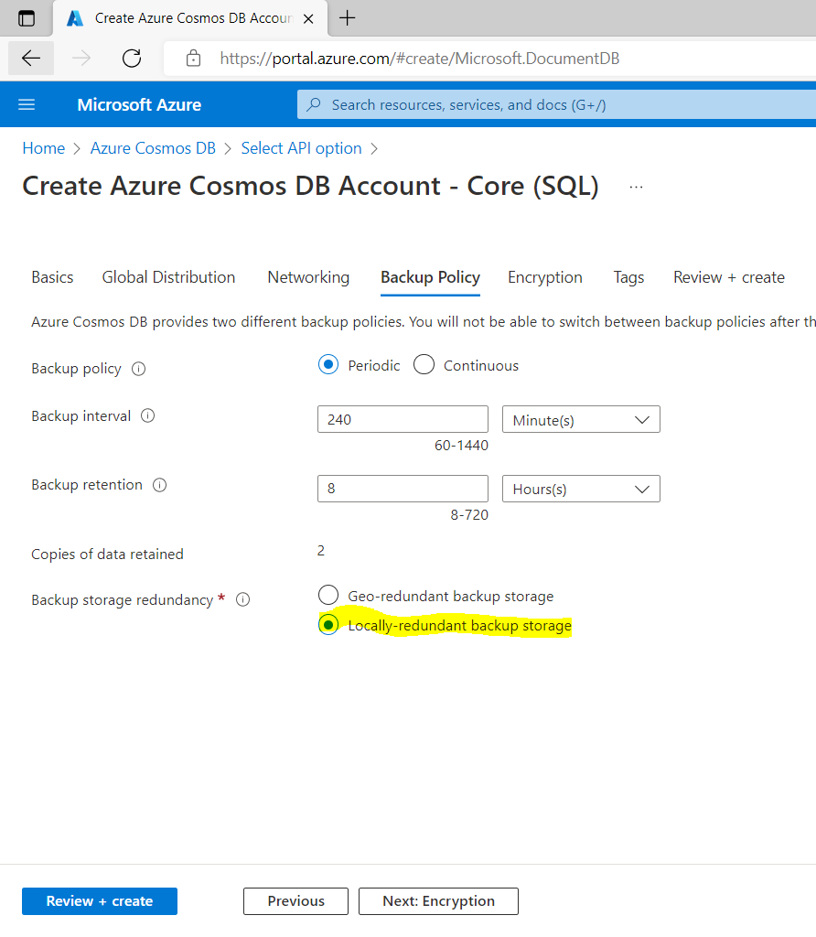

Below screen will appear then click on Go to resource.

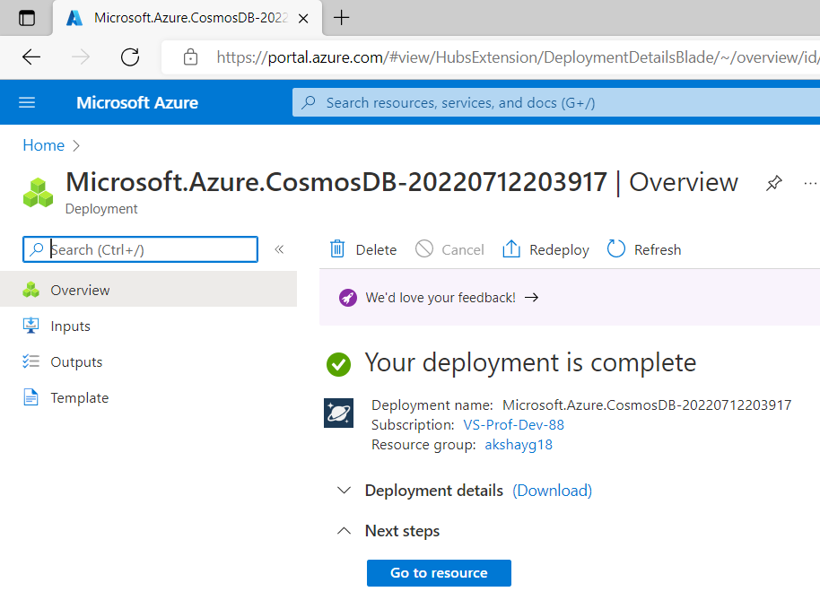

After that below screen will appear. Click on Add Container (highlighted)

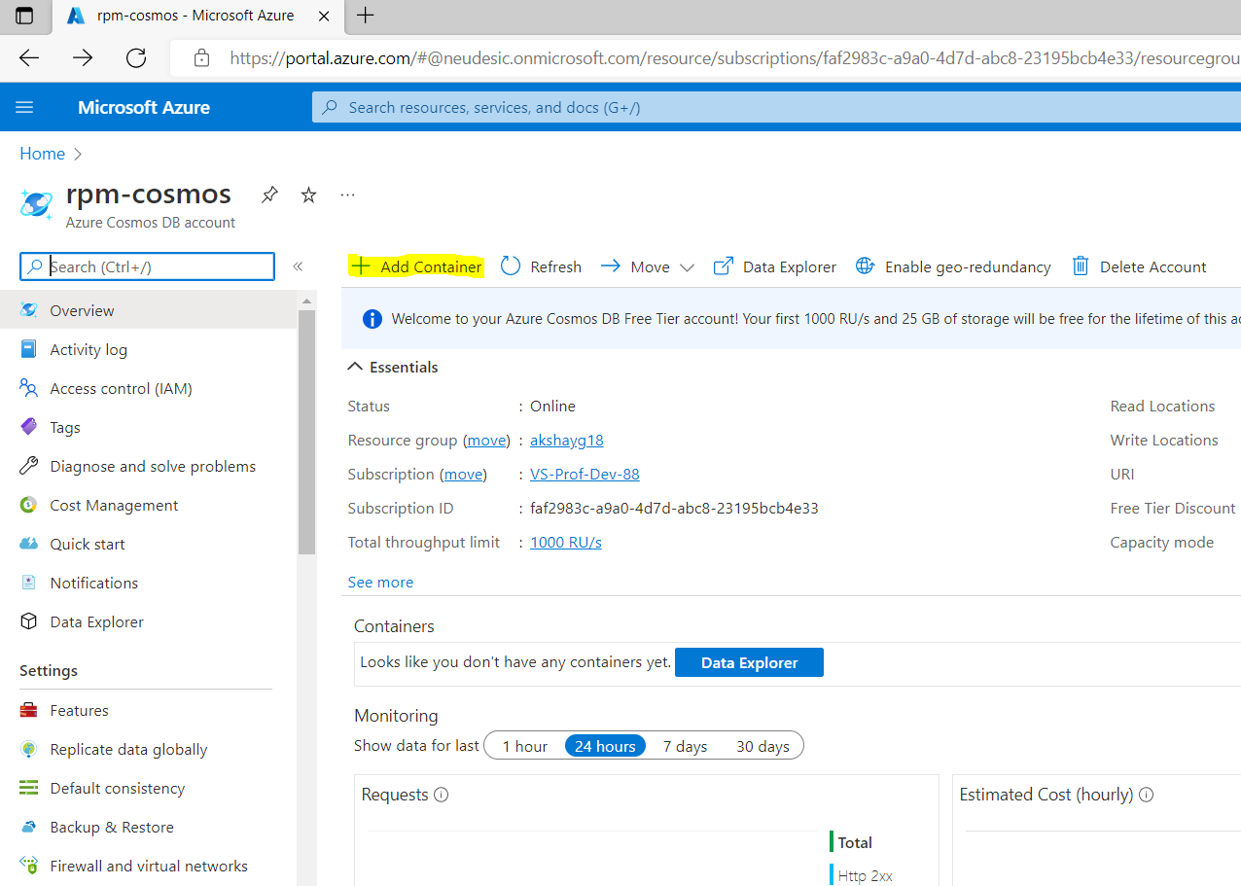

Below screen will appear then specify the Database id, Database Max RU/s (100), Container id & leave rest details to default then click on Ok

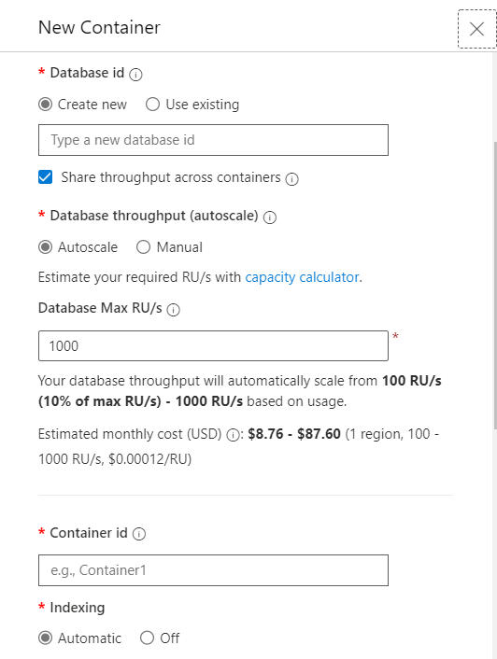

1. Replace the values for variables in “Param_File.py”. Refer the comments specified in the same file

Steps on Local Machine –

Replace the connection string for Event Hub Namespace and Event Hub Instance to make it ready for execution. This refers to line 19 in the code.